|  |  |  |
| --- | --- | --- |
| ipn | **INSTITUTO POLITÉCNICO NACIONAL**  **ESCUELA SUPERIOR DE CÓMPUTO** |  |

**Cryptography**

**“Operation modes”**

Abstact

Here we are going to see how to encrypt and decrypt using 4 types of operation modes, and how to apply them to encrypt images.

**By:**

**Josué Ruíz Hernández**

Professor:

MSc. NIDIA ASUNCIÓN CORTEZ DUARTE

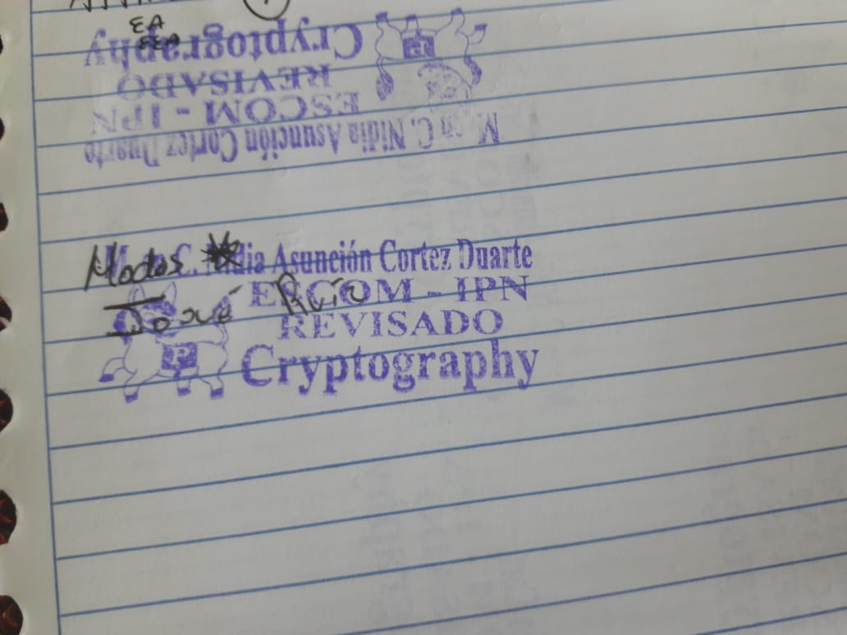

March 2017

Contenido

Introduction 3

Literature review 4

Electronic Code Book (ECB) 4

Cipher Block Chaining 5

Cipher Feedback Mode (CFB) 7

Output Feedback Mode 7

Software 9

Procedure 9

Results 13

Discussions 26

Conclusions 26

References 26

Code 27

# Introduction

Block cipher is an encryption algorithm which takes fixed size of input say b bits and produces a ciphertext of b bits again. If input is larger than b bits it can be divided further. For different applications and uses, there are several modes of operations for a block cipher.

There exist 4 modes of operation: Electronic Cipher Block, Cipher Block Channing, Cipher Feed Back, Output Feed Back and all have both advantages and disadvantages, that’s why one mode is more useful than other one in one situation, for example ECB is not very convenient if we are going to cipher images with few colors like the Japanese flag.

These operations modes can cipher plain texts, images and whatever we want if they can be separated in blocks. The block size depends of the algorithm that we are going to use, for example the block size is of 64 bytes if we are going to use the DES algorithm, but if we want to use the AES algorithm the block size must be of 128 bytes.

We can use others cypher algorithms like Hill but is not as efficient like AES one, but we can implement manually easier than if we want to implement DES algorithm without using the libraries.

We can cipher using this operation modes in a lot of programming languages like python, rubi, c++ and java. For this experiment we are going to use java as our programming language because it is easier to use in terms of interfaces and it count with a lot of methods that can make us the work easier.

# Literature review

Electronic Code Book (ECB)  
Electronic code book is the easiest block cipher mode of functioning. It is easier because of direct encryption of each block of input plaintext and output is in form of blocks of encrypted ciphertext. Generally, if a message is larger than b bits in size, it can be broken down into bunch of blocks and the procedure is repeated.

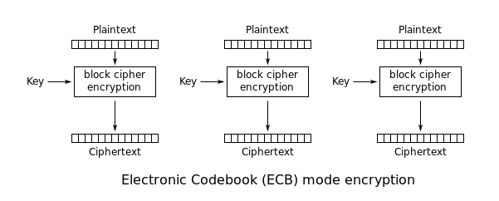

The encryption formula is:

$$C_{j}=E(P_{j})$$

Where:

C is the block j cyphered of the plain text

E is the cypher function (AES/DES/HILL)

P is the block j of the plain text

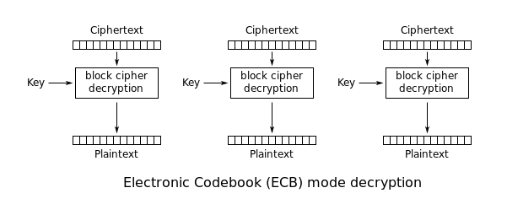

The decryption formula is:

$$P_{j}=D(C_{j})$$

Where

C is the block j cyphered of the plain text

D is the decipher function (AES/DES/HILL)

P is the block j of the plain text

**Advantages of using ECB –**

* Parallel encryption of blocks of bits is possible, thus it is a faster way of encryption.
* Simple way of block cipher.

**Disadvantages of using ECB –**

* Prone to cryptanalysis since there is a direct relationship between plaintext and ciphertext.

Cipher Block Chaining

Cipher block chaining or CBC is an advancement made on ECB since ECB compromises some security requirements. In CBC, previous cipher block is given as input to next encryption algorithm after XOR with original plaintext block. In a nutshell here, a cipher block is produced by encrypting a XOR output of previous cipher block and present plaintext block.

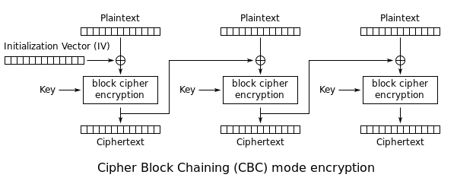

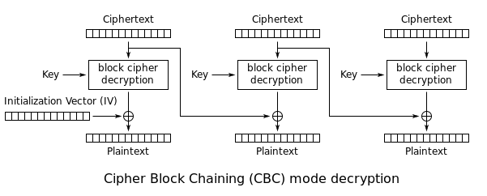

The encryption equation is:

$$C_{j}=E(P_{j}⊕ C_{j-1})$$

The decryption equation is:

$$P_{j}=D(C_{j})⊕C_{j-1}$$

**Advantages of CBC**

* CBC works well for input greater than *b* bits.
* CBC is a good authentication mechanism.
* Better resistive nature towards cryptanalsis than ECB.

**Disadvantages of CBC**

* Parallel encryption is not possible since every encryption requires previous cipher.

Cipher Feedback Mode (CFB)  
In this mode the cipher is given as feedback to the next block of encryption with some new specifications: first an initial vector IV is used for first encryption and output bits are divided as set of s and b-s bits the left-hand side s-bits are selected and are applied an XOR operation with plaintext bits. The result given as input to a shift register and the process continues. The encryption and decryption process for the same is shown below, both use encryption algorithm.

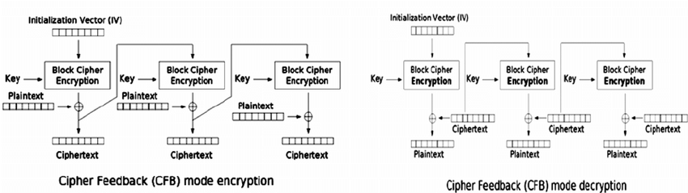

The encryption equation is:

$$C_{j}=E(C_{j-1})⊕P_{j}$$

The decryption equation is:

$$P_{j}=C_{j}⊕D(C_{j-1})$$

**Advantages of CFB**

* Since, there is some data loss due to use of shift register, thus it is difficult for applying cryptanalysis.

Output Feedback Mode  
The output feedback mode follows nearly same process as the Cipher Feedback mode except that it sends the encrypted output as feedback instead of the actual cipher which is XOR output. In this output feedback mode, all bits of the block are sent instead of sending selected s bits. The Output Feedback mode of block cipher holds great resistance towards bit transmission errors. It also decreases dependency or relationship of cipher on plaintext.

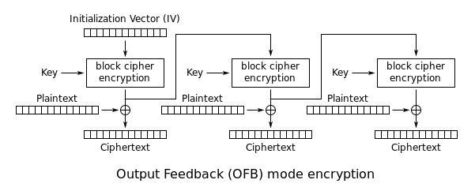

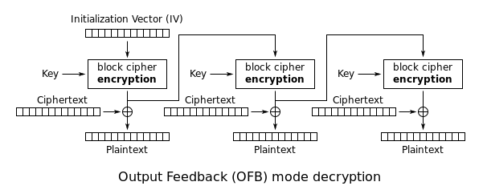

The encryption equation is:

$$C_{j}=E_{j}(C_{0})⨁P_{j}$$

Where the j is the number of the block and $E_{j}$ the times that $C_{0}$ has been encrypted.

The decryption equation is:

$$P_{j}=D_{j}(C_{0})⨁C_{j}$$

Where the j is the number of the block and $D_{j}$ is the times that $C_{0}$ has been decrypted.

# Software

1. NetBeans as the development environment
2. Java as the programming language
3. Javax.crypto.* as the library to encrypt and decrypt the images

# Procedure

Encrypt

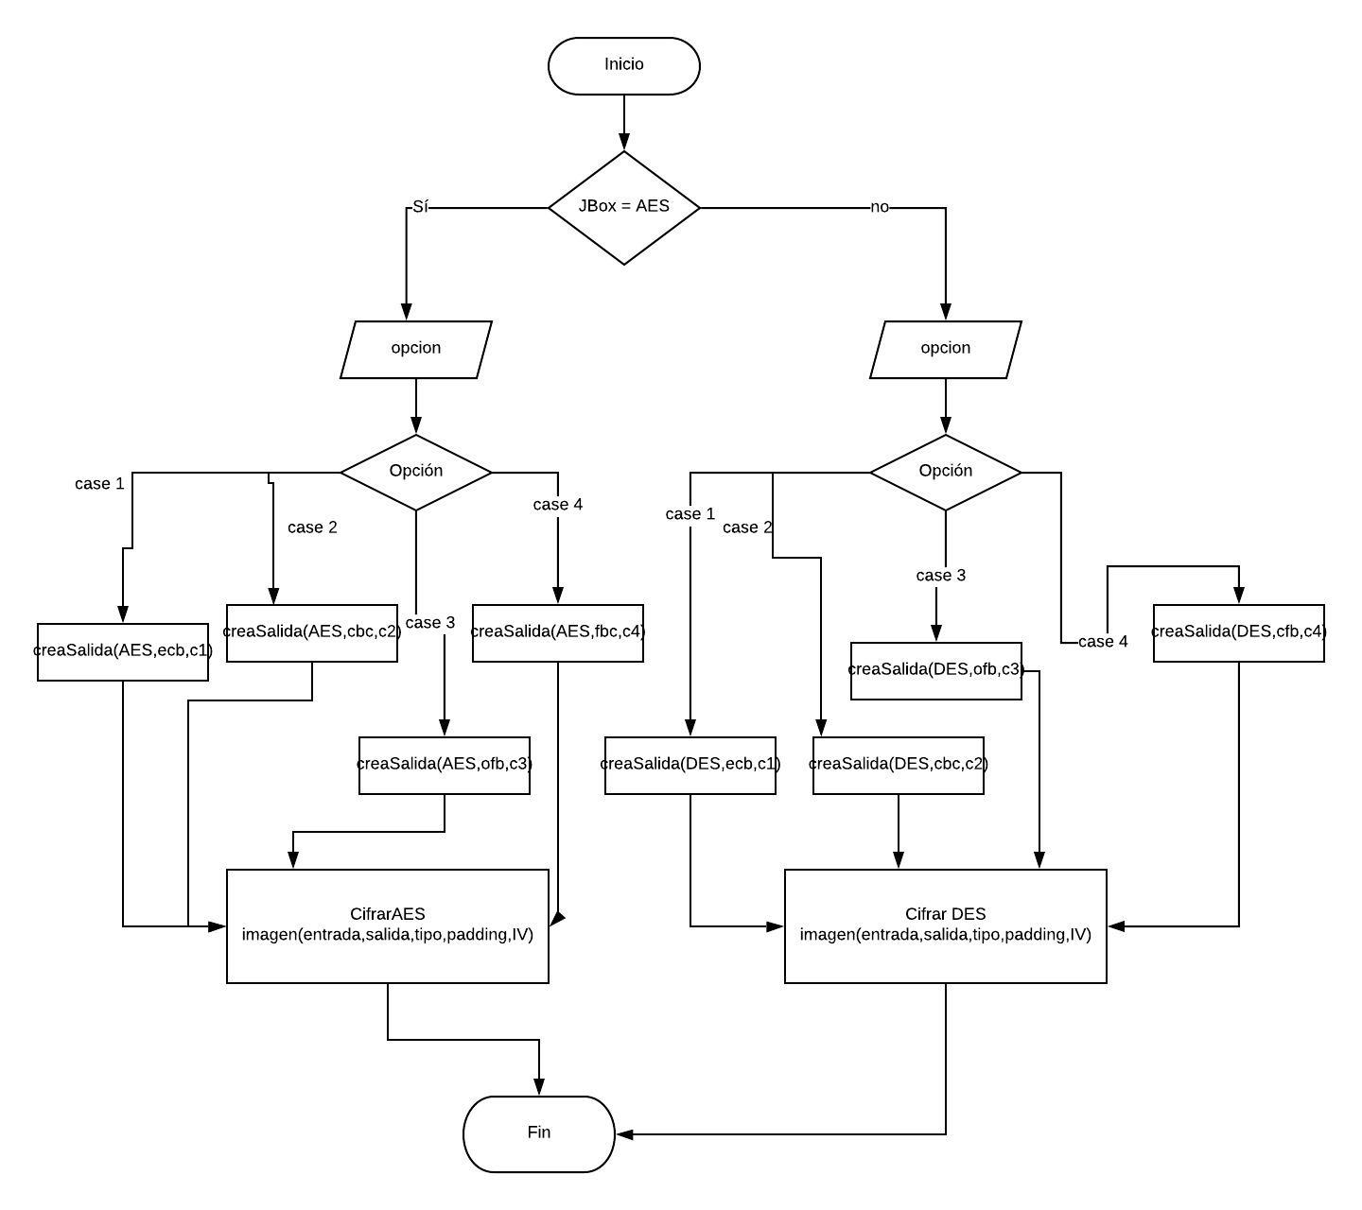

Decrypt

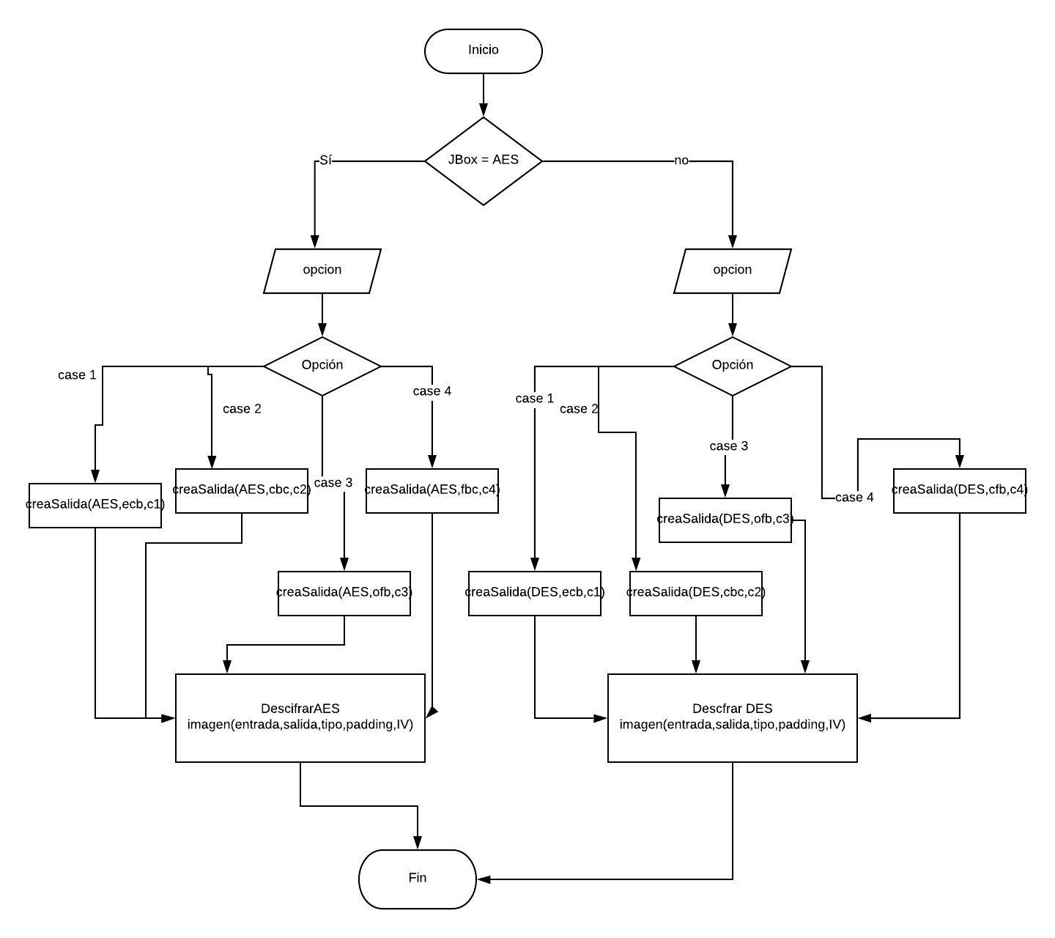

Create output

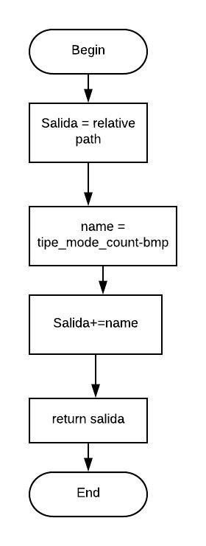

Encrypt

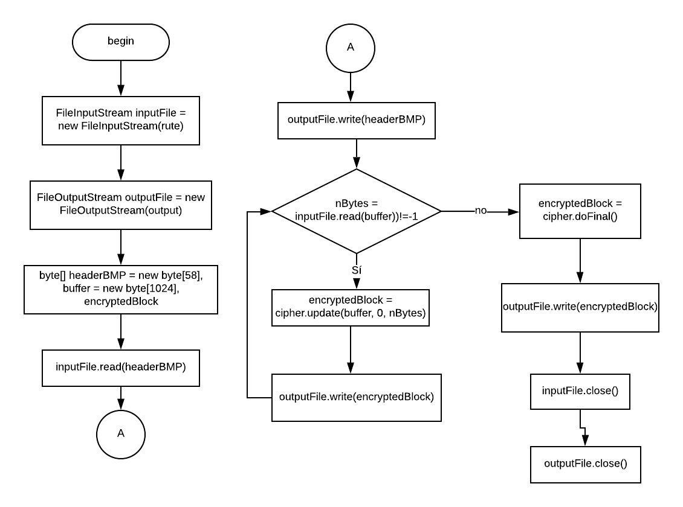

Decrypt

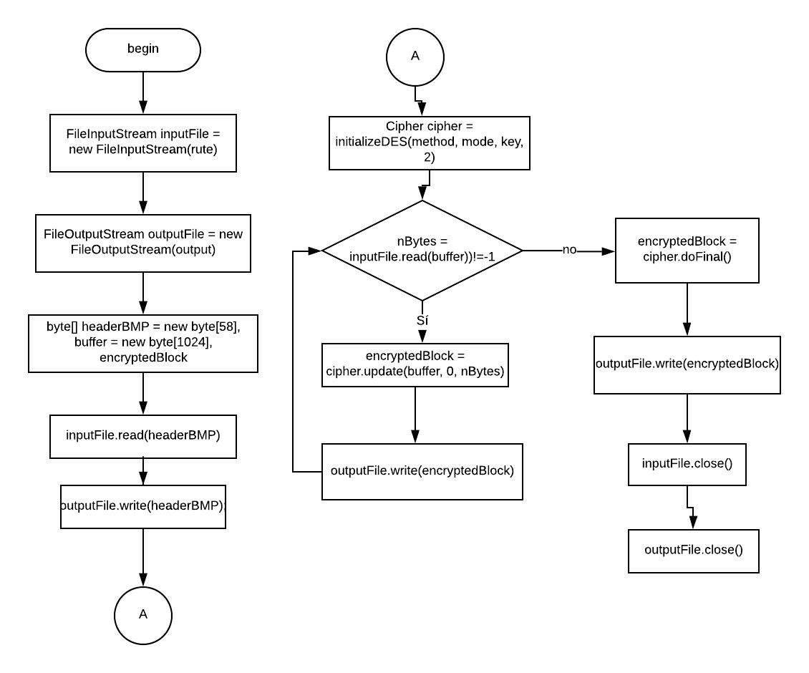

# Results

Let’s make a proof using the meme:

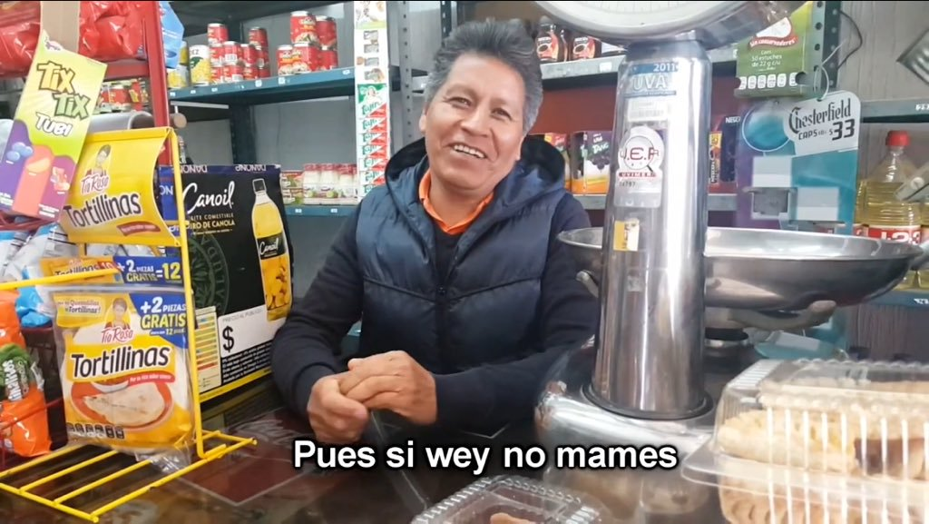

For this example, we are going to use the AES algorithm

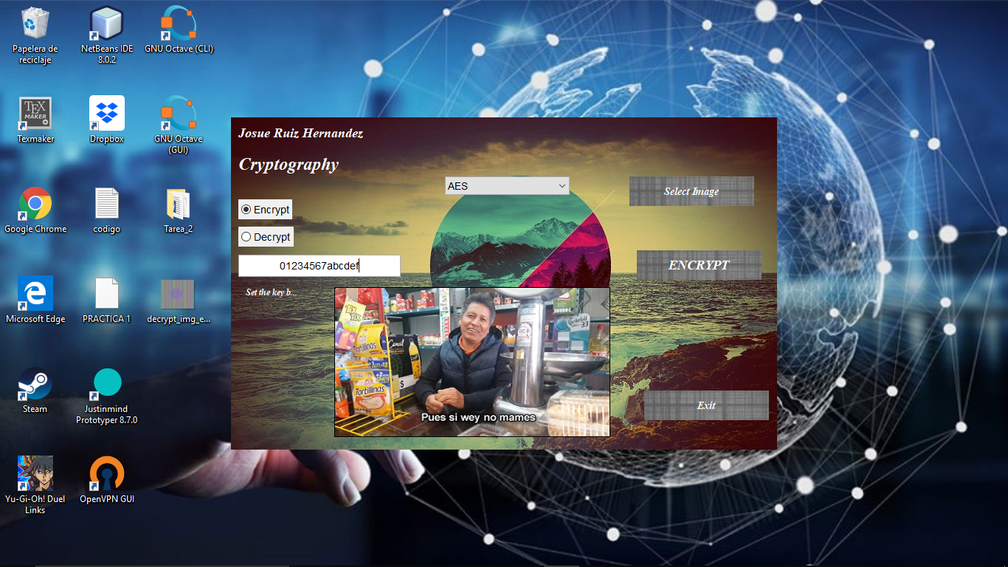

We are going to encrypt it in the order:

1. ECB
2. CBC
3. OFB
4. CFB

And obviously the order to decrypt it is the same

1. Encrypt with ECB:

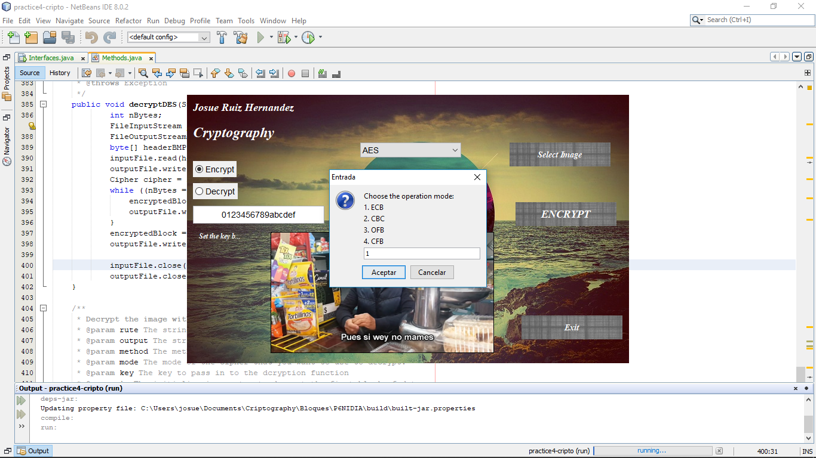

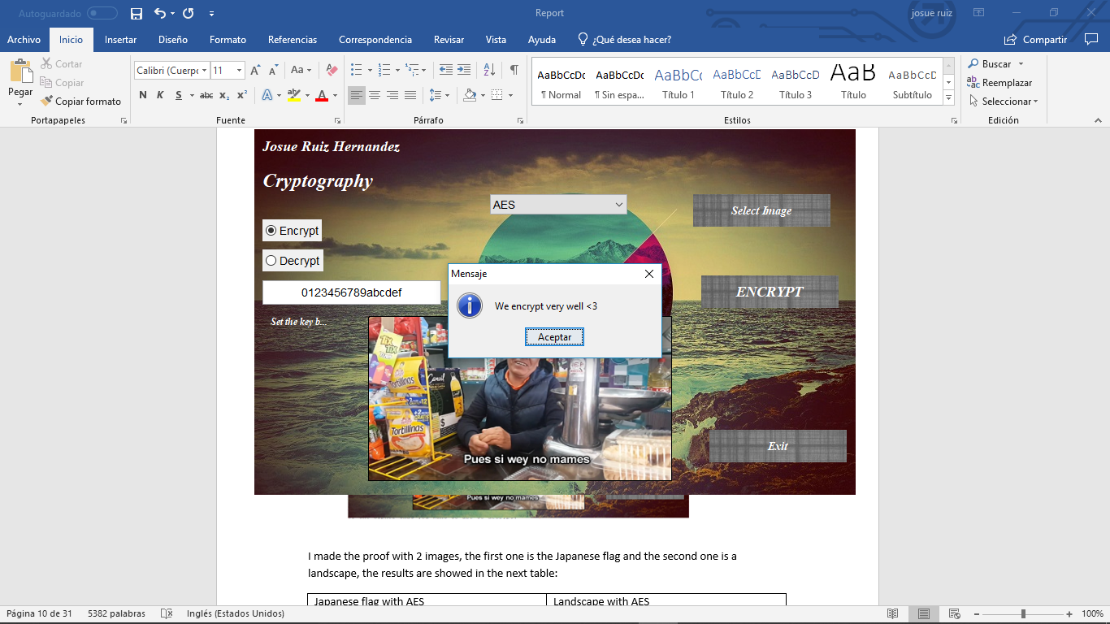

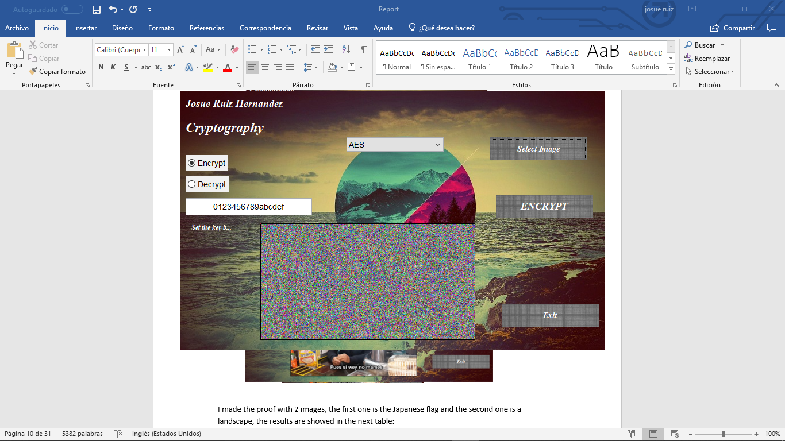

1. Encrypt it using CBC

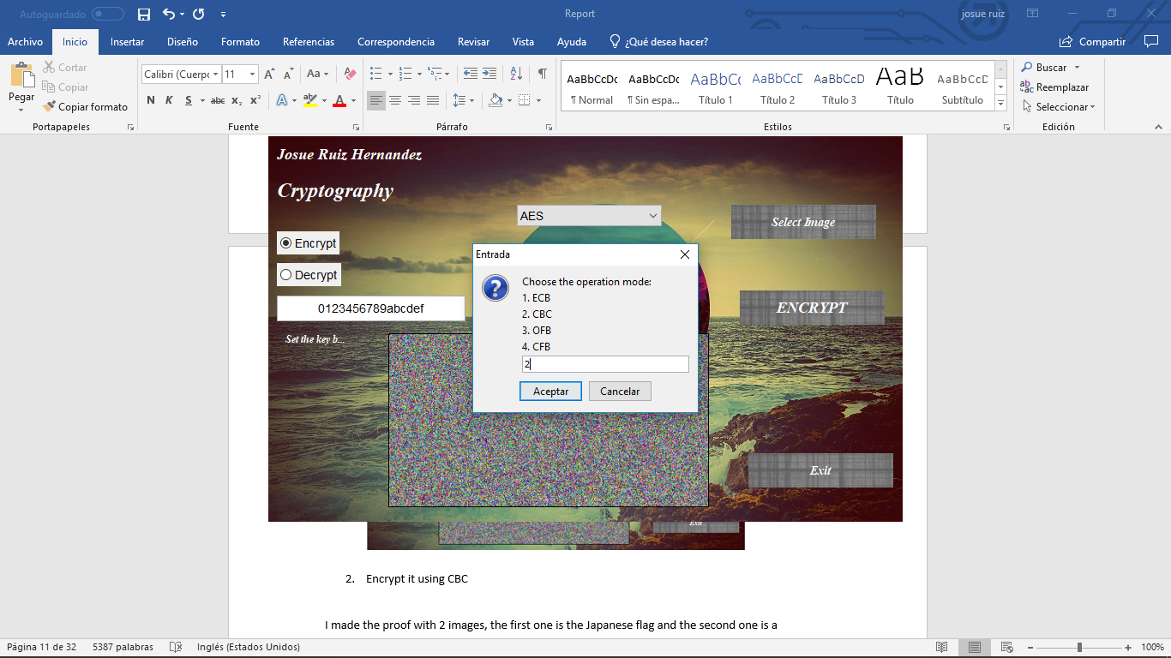

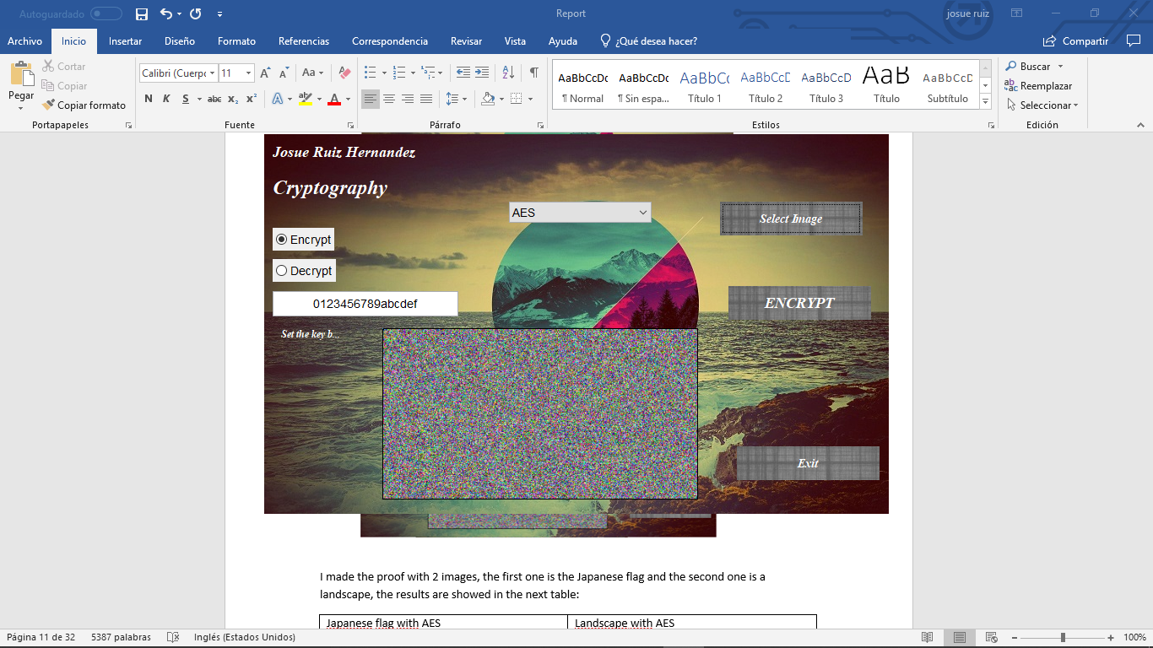

1. Using OFB

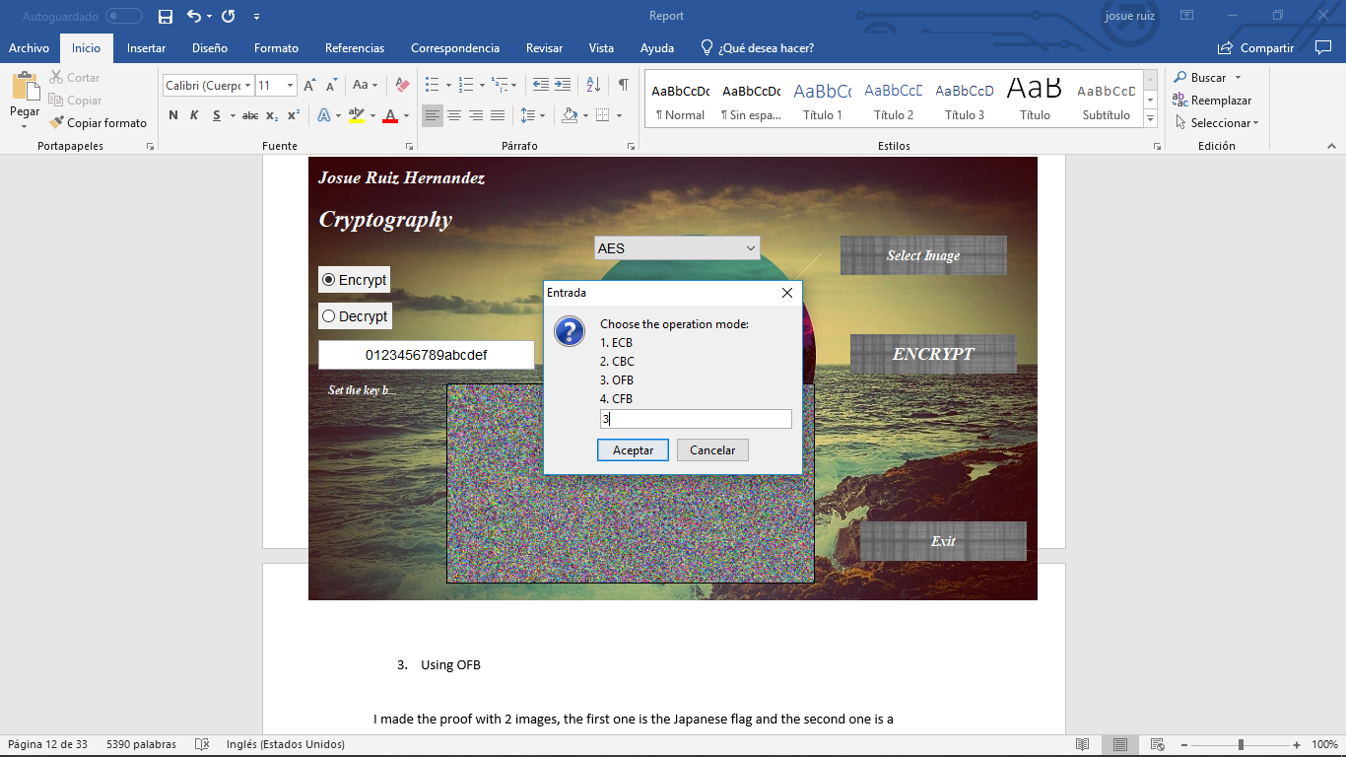

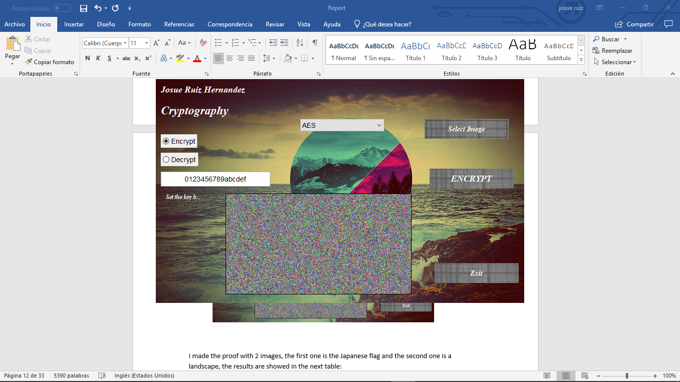

1. Using CFB

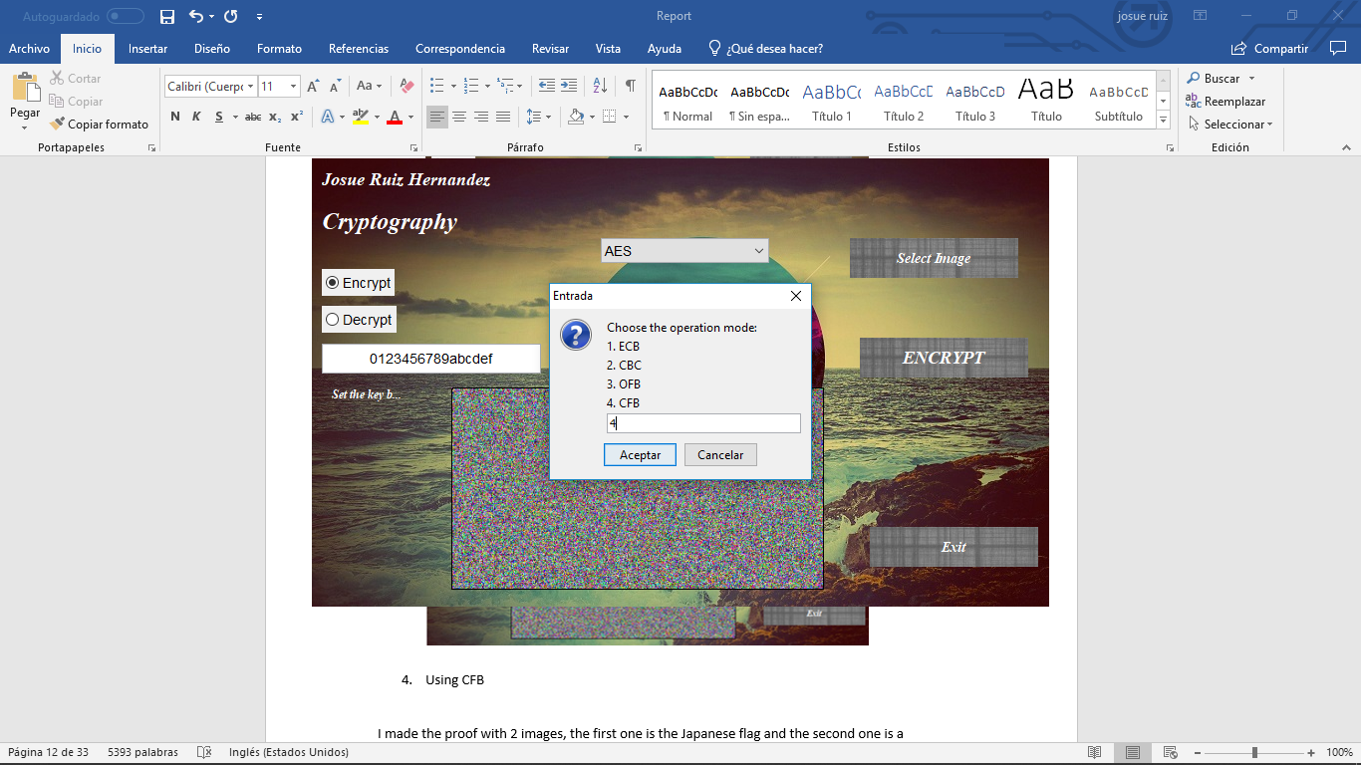

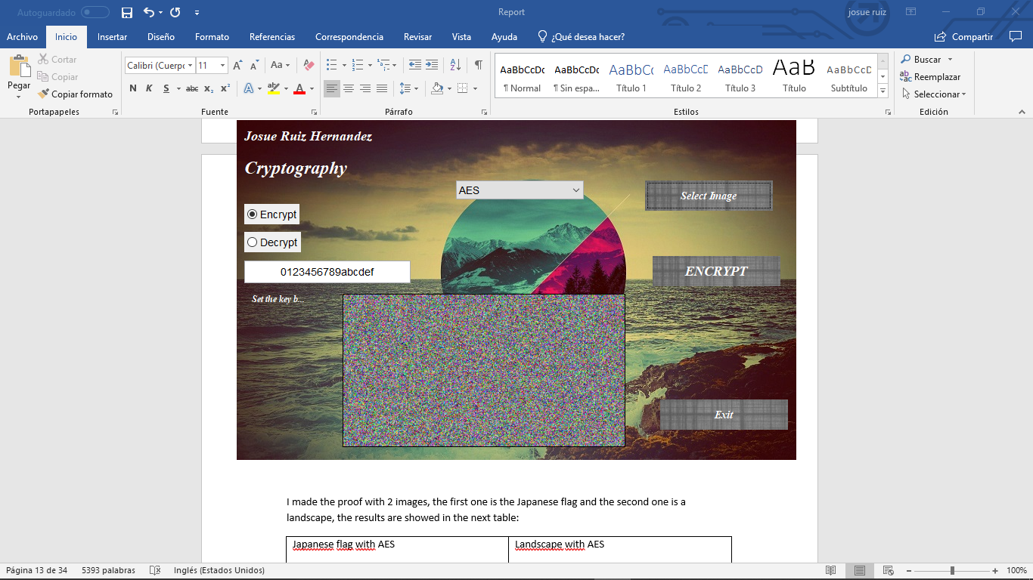

1. Let´s decrypt using CFB

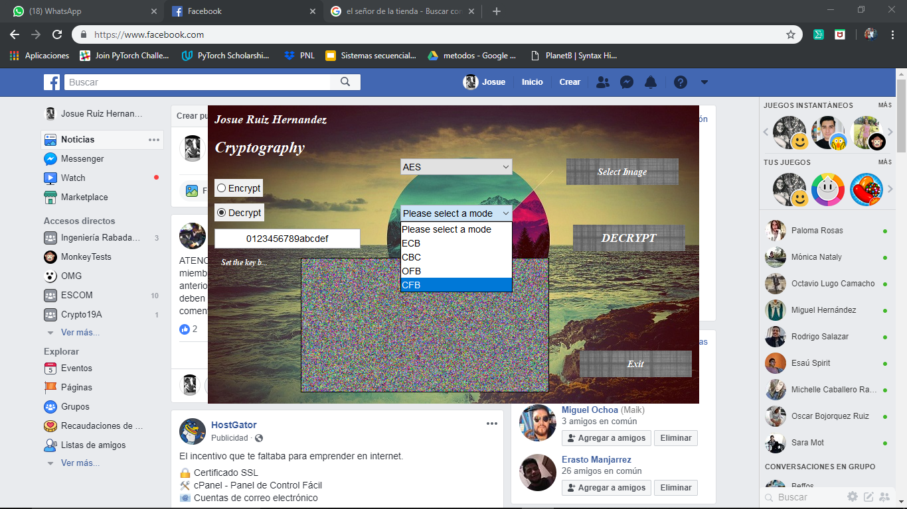

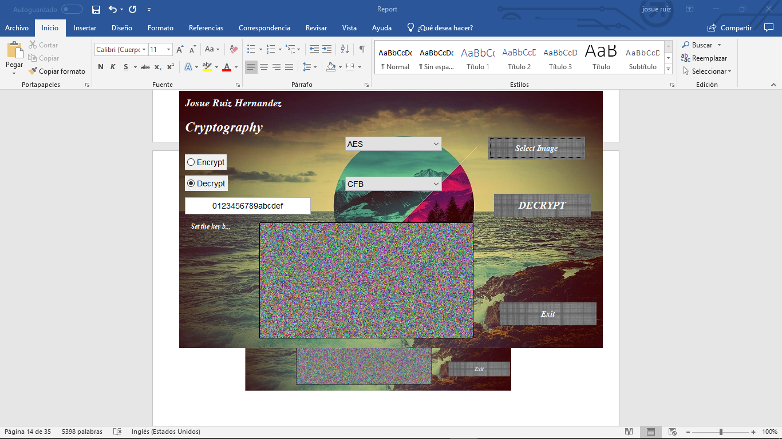

1. Now using OFB

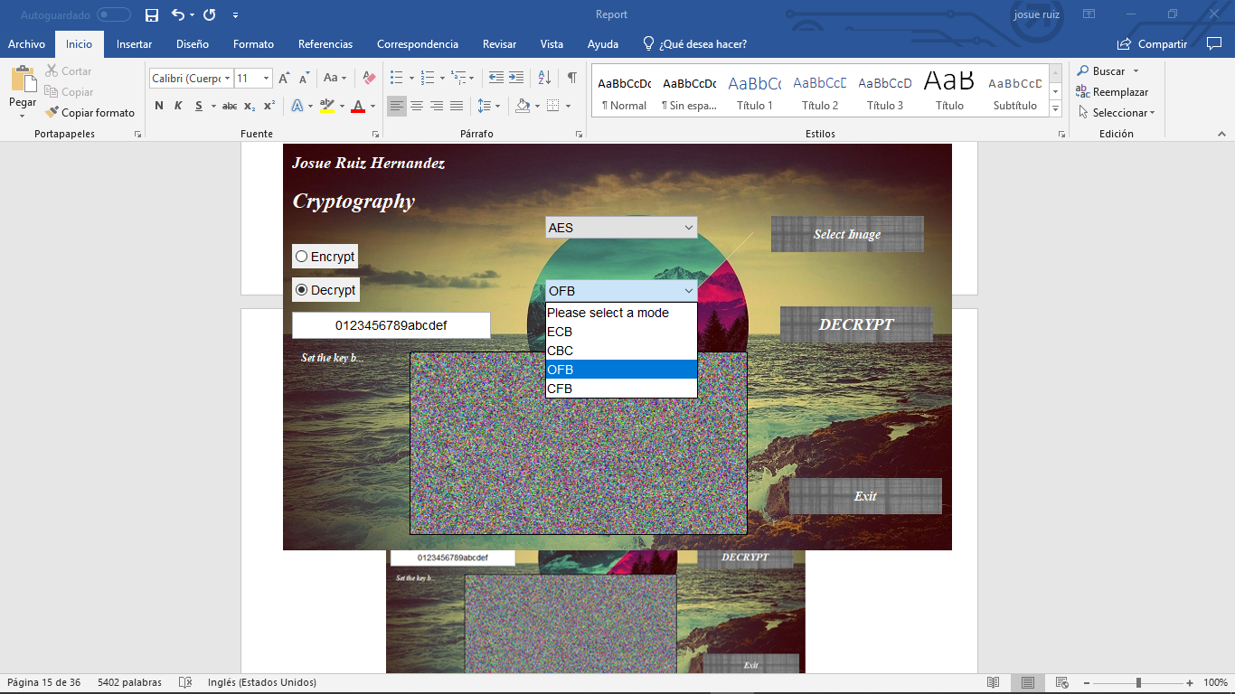

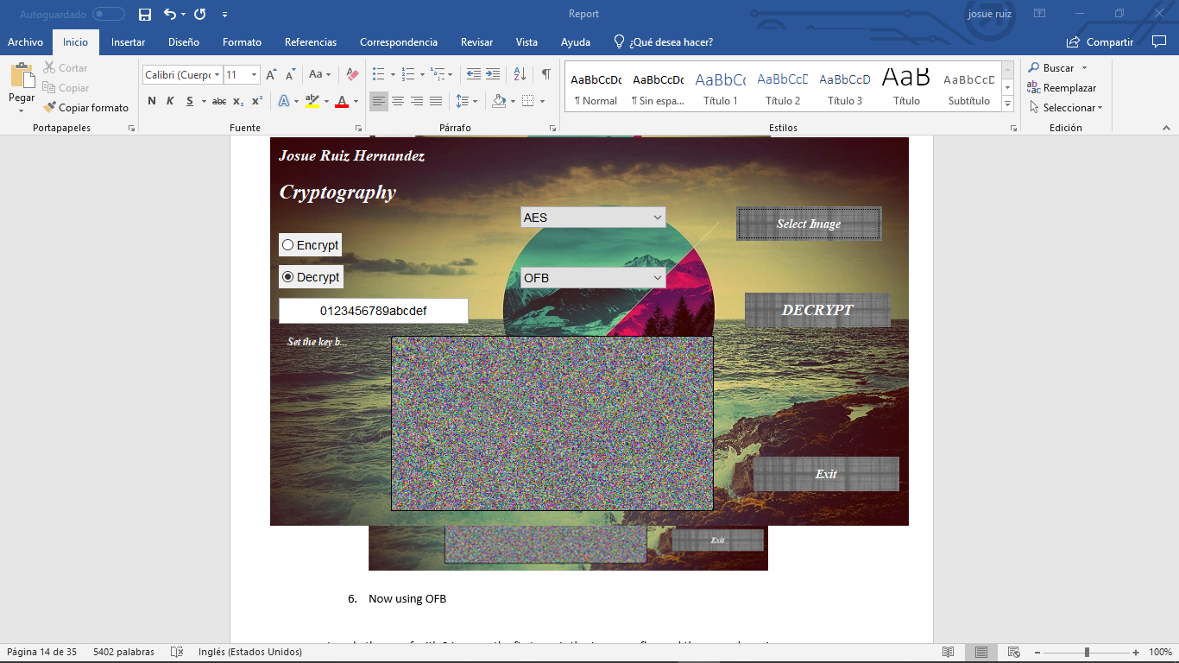

1. Using CBC

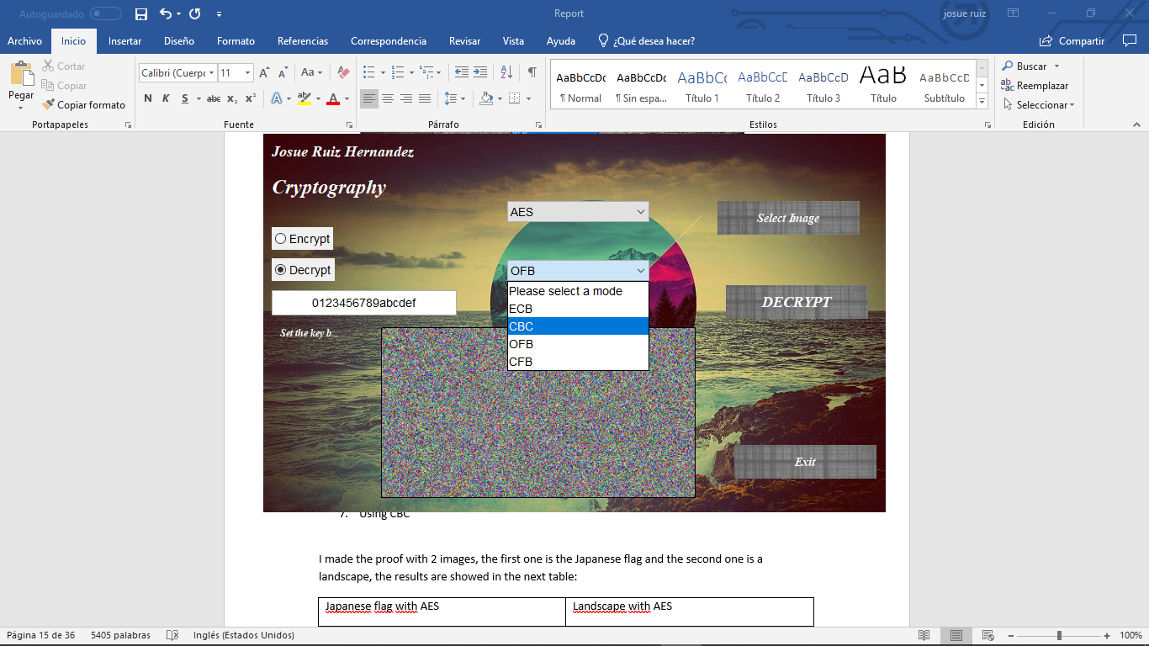

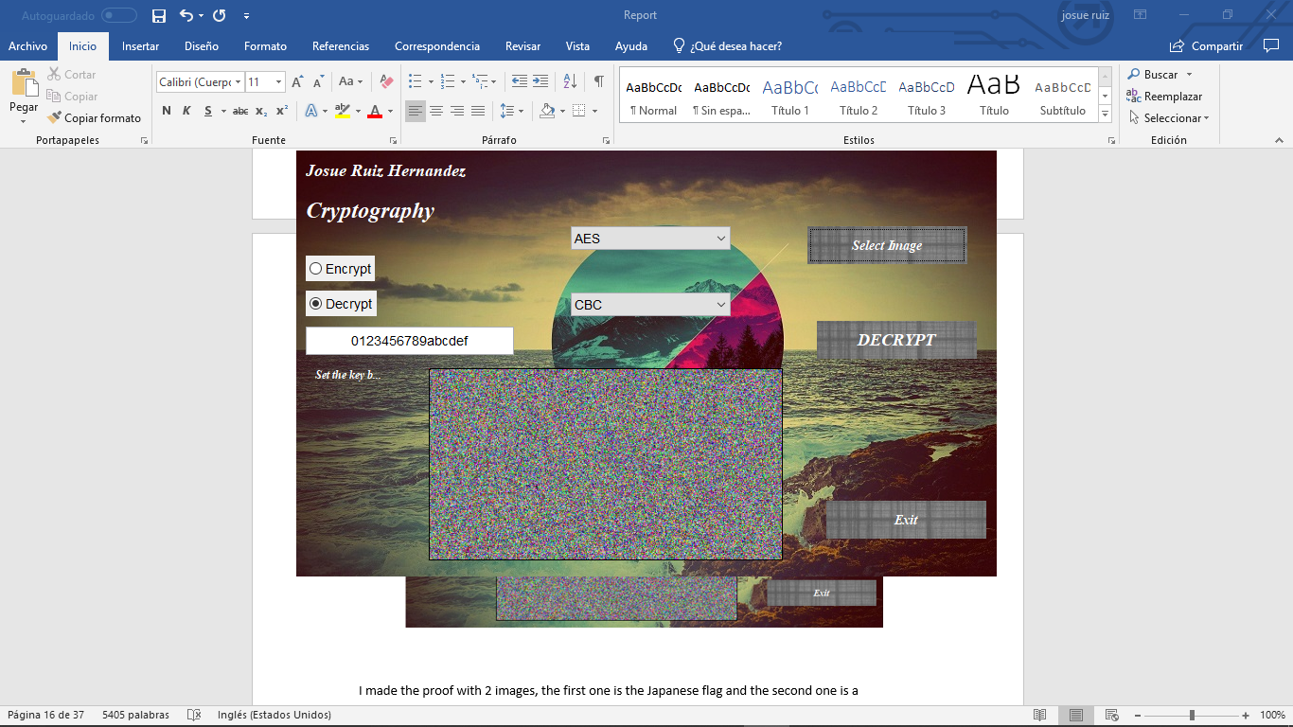

1. Finally using EBC

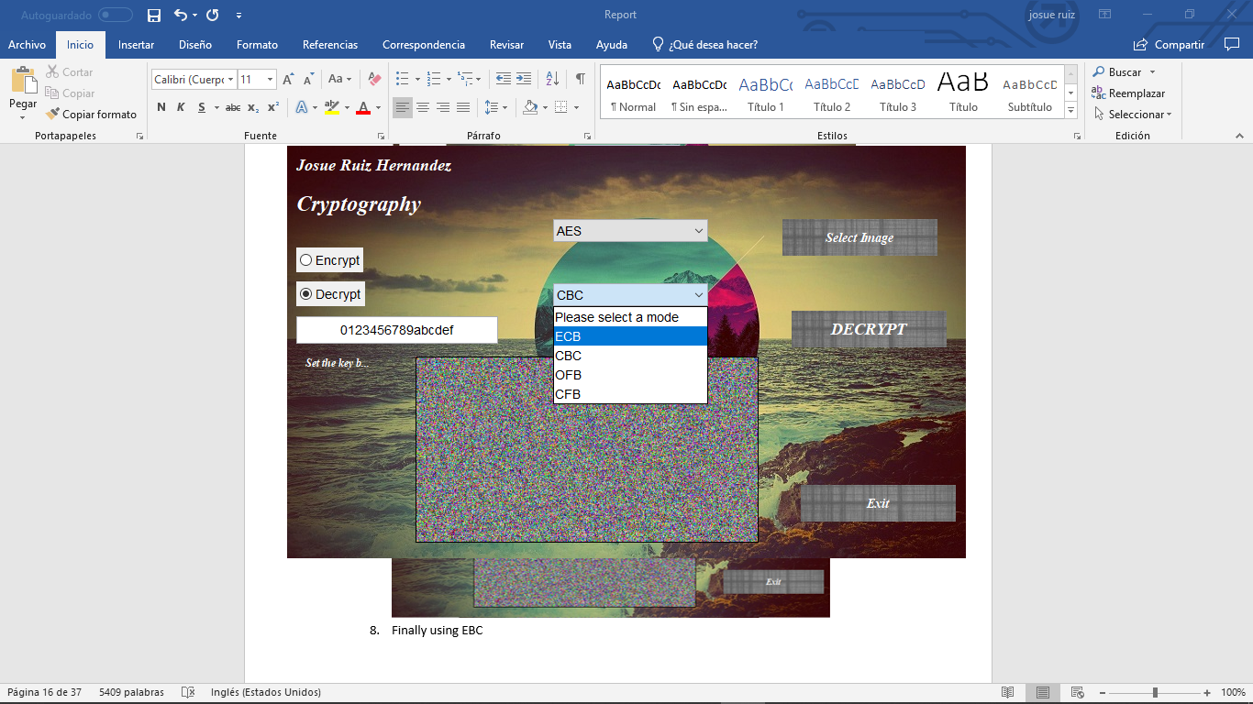

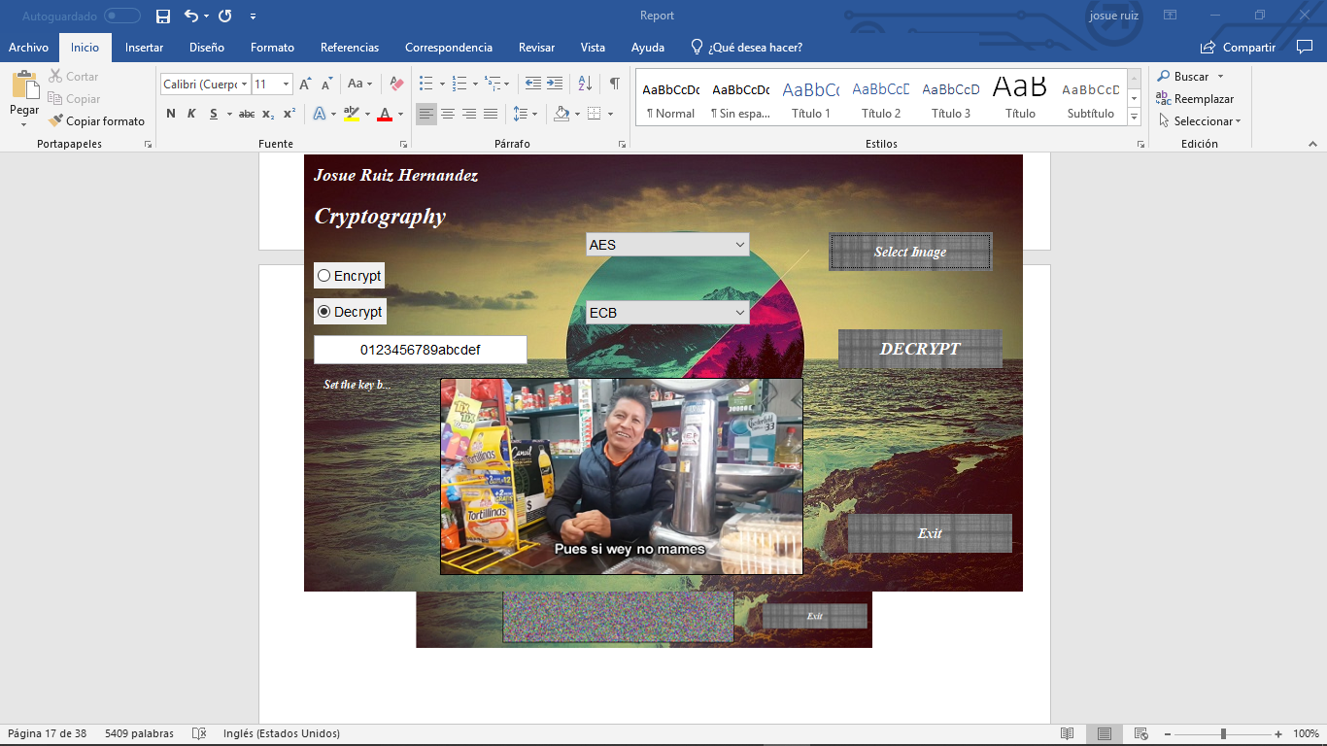

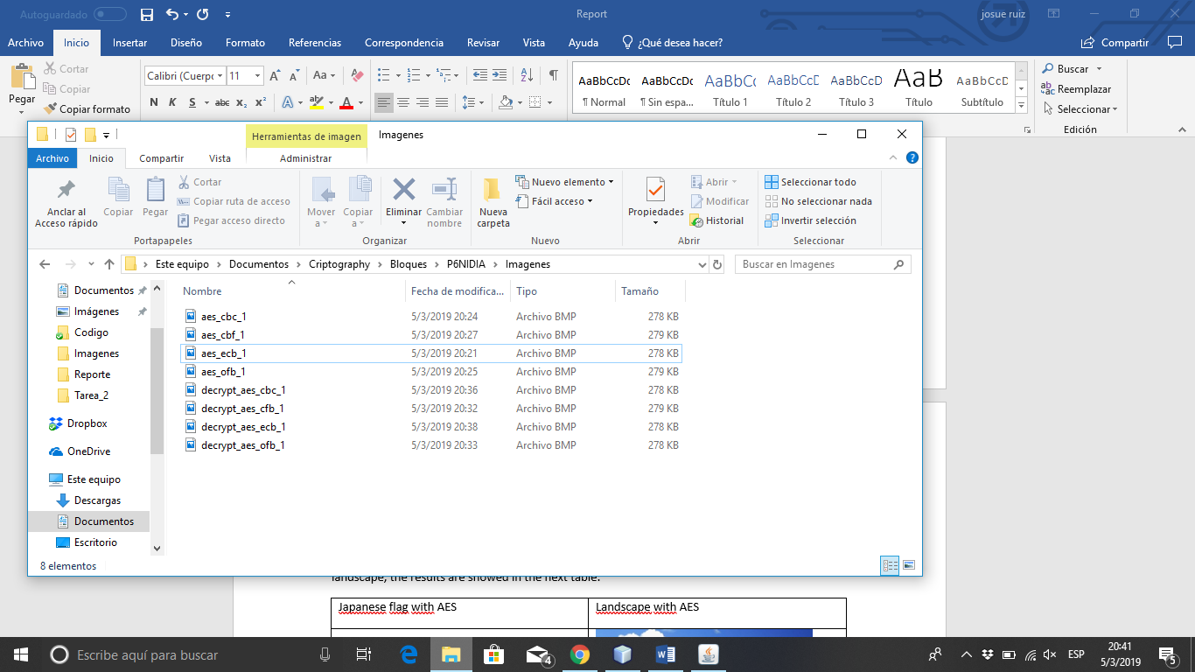

That’s are the images that the program created

I made the proof with 2 images, the first one is the Japanese flag and the second one is a landscape, the results are showed in the next table:

|  |  |
| --- | --- |
| Japanese flag with AES | Landscape with AES |
|  |  |
|  |  |
|  |  |
|  |  |
|  |  |

|  |  |
| --- | --- |
| Japanese flag with DES | Landscape with DES |
|  |  |
|  |  |
|  |  |
|  |  |
|  |  |

# Discussions

This practice was one of the hardest practices that I have done, first at all I didn’t know hot to implement the operation modes in Java, before I used the AES cypher to encrypt a text and decrypt it again, that’s why I knew more less how to implement the algorithm in this practice but I didn’t know how to separate the bytes in blocks to cypher them and use the padding, the fiery otters and me tried in a lot of ways to finally realize that we can cypher the entire block and get it cyphered using the correct padding in the function´s parameter. I though that we had to create a lot of functions, one per mode and encryption algorithm, 16 functions to encrypt and 16 to decrypt but instead of that only made 4, 2 to encrypt and 2 to decrypt only changing the parameters in the A/D button using cases. If we decide to cypher the image then instead of choosing the mode we made all the modes and create an image for those modes, but if the user decide decrypt one image, then he can decide the operation mode in which de want to decrypt it.

It was hard, but we finally could <3

# Conclusions

The operation modes let us make block ciphers using cryptography methods like AES, DES or Hill. Depending the operation mode that we choose the cipher would be more or less complex in our text or image, for example in the Japanese flag if we use the ECB mode we can still see the circle in the middle of the image and if one person catch it interfering the communication he can realize that I´m sending an image related to the Japanese flag, but if I send a image with a lot of figures and colors ECB work perfectly. All the modes have advantages and disadvantages, for example in CBC if one block is corrupted then the next block is going to be wrong too.

# References

Paar, C. Pelzl ,J. Preneel B. (2009) *″Understanding Cryptography: A textbook for students and practitioners.″* United States of America: Ed. Springer Verlag. ISBN-13: 978-3642041006.  
  
Stallings, W. (2010) *″Cryptography and network security.″* (5a Ed.). United States of America: Ed. Prentice Hall. ISBN-13: 978-00136097044.

Anonimous. (15-06-2017). *Operation modes*. Geek fors Geeks. Geek Recuperado de <https://www.geeksforgeeks.org/computer-network-block-cipher-modes-of-operation/>

# Code

1. **package** pack;
3. **import** java.awt.Image;
4. **import** java.io.File;
5. **import** java.io.FileInputStream;
6. **import** java.io.FileOutputStream;
7. **import** java.io.IOException;
8. **import** java.security.InvalidAlgorithmParameterException;
9. **import** java.security.InvalidKeyException;
10. **import** java.security.NoSuchAlgorithmException;
11. **import** javax.crypto.Cipher;
12. **import** javax.crypto.NoSuchPaddingException;
13. **import** javax.crypto.SecretKey;
14. **import** javax.crypto.SecretKeyFactory;
15. **import** javax.crypto.spec.DESKeySpec;
16. **import** javax.crypto.spec.IvParameterSpec;
17. **import** javax.crypto.spec.SecretKeySpec;
18. **import** javax.imageio.ImageIO;
19. **import** javax.swing.Icon;
20. **import** javax.swing.ImageIcon;
21. **import** javax.swing.JFileChooser;
22. **import** javax.swing.JLabel;
23. **import** javax.swing.filechooser.FileNameExtensionFilter;
25. /**
26. *
27. * @author Josue
28. This clas contains all the Methods to be used in the Practice of AES and DES ciphers
29. */
30. **public** **class** Methods {

33. /**
34. * Obtain the rute of a file
35. * @return Returns a String with the rute of the file that is selected on the FileChooser if the rute can not be obtained returns null
36. */
37. **public** String rute(){
38. FileNameExtensionFilter filter = **new** FileNameExtensionFilter("Imagen BMP", "bmp");
39. String rute = "";
40. File d = **new** File("C:\\Users\\josue\\Documents\\Criptography\\Bloques\\P6NIDIA\\Imagenes");
41. **try** {
42. JFileChooser chooser = **new** JFileChooser();
43. chooser.setFileFilter(filter);
44. chooser.setDialogTitle("SELECT BMP");
45. chooser.setCurrentDirectory(d);
46. **int** option = chooser.showOpenDialog(chooser);
47. **if**(option == JFileChooser.APPROVE_OPTION){
48. File f = chooser.getSelectedFile();
49. rute = f.getAbsolutePath();
50. **return** rute;
51. }
52. }
53. **catch**(Exception e) {
54. System.out.println(e.getMessage());
55. }
56. **return** **null**;
57. }
59. /**
60. * Set an image in a JLabel
61. * @param rute The string that has rute of the image
62. * @param label The JLabel where you want to put the image
63. * @throws java.io.IOException
64. */
65. **public** **void** showImg(String rute, JLabel label) **throws** IOException{
66. File f = **new** File(rute);
67. Image image = ImageIO.read(f);
68. ImageIcon icon = **new** ImageIcon(image);
69. Icon icono = **new** ImageIcon(icon.getImage().getScaledInstance(label.getWidth(), label.getHeight(), Image.SCALE_SMOOTH));
70. label.setText(**null**);
71. label.setIcon(icono);
72. }
74. /**
75. * Encrypt the image with the AES method
76. * @param rute The string that has rute of the image
77. * @param output The string of the path where you want to save the encrypted image
78. * @param method The method that you want to use to cipher.
79. * @param mode The mode of the cipher that you want to use to encrypt
80. * @param key The key to pass in to the encryption function
81. * @throws java.lang.Exception
82. */
83. **public** **void** encrypt(String rute, String output, String method, String mode, String key) **throws** Exception {
84. **int** nBytes;
85. FileInputStream inputFile = **new** FileInputStream(rute);
86. FileOutputStream outputFile = **new** FileOutputStream(output);
87. **byte**[] headerBMP = **new** **byte**[58], buffer = **new** **byte**[1024], encryptedBlock;
88. inputFile.read(headerBMP);
89. outputFile.write(headerBMP);
90. Cipher cipher = initialize(method, mode, key, 1);
91. **while** ((nBytes = inputFile.read(buffer))!=-1) {
92. encryptedBlock = cipher.update(buffer, 0, nBytes);
93. outputFile.write(encryptedBlock);
94. }
95. encryptedBlock = cipher.doFinal();
96. outputFile.write(encryptedBlock);
98. inputFile.close();
99. outputFile.close();
100. }
102. /**
103. * Encrypt the image with the AES method
104. * @param rute The string that has rute of the image
105. * @param output The string of the path where you want to save the encrypted image
106. * @param method The method that you want to use to cipher.
107. * @param mode The mode of the cipher that you want to use to encrypt
108. * @param key The key to pass in to the encryption function
109. * @param iv The initializacion vector to encrypt the first block of data.
110. * @throws Exception
111. */
112. **public** **void** encrypt(String rute, String output, String method, String mode, String key, String iv) **throws** Exception {
113. **int** nBytes;
114. FileInputStream inputFile = **new** FileInputStream(rute);
115. FileOutputStream outputFile = **new** FileOutputStream(output);
116. **byte**[] headerBMP = **new** **byte**[58], buffer = **new** **byte**[1024], encryptedBlock;
117. inputFile.read(headerBMP);
118. outputFile.write(headerBMP);
119. Cipher cipher = initialize(method, mode, key, iv, 1);
120. **while** ((nBytes = inputFile.read(buffer))!=-1) {
121. encryptedBlock = cipher.update(buffer, 0, nBytes);
122. outputFile.write(encryptedBlock);
123. }
124. encryptedBlock = cipher.doFinal();
125. outputFile.write(encryptedBlock);
127. inputFile.close();
128. outputFile.close();
129. }
131. /**
132. * Decrypt the image with the AES method
133. * @param rute The string that has rute of the encrypted image
134. * @param output The string of the path where you want to save the decrypted image
135. * @param method The method that you want to use to decrypt.
136. * @param mode The mode of the cipher that you want to use to decrypt.
137. * @param key The key to pass in to the dcryption function
138. * @throws Exception
139. */
140. **public** **void** decrypt(String rute, String output, String method, String mode, String key) **throws** Exception {
141. **int** nBytes;
142. FileInputStream inputFile = **new** FileInputStream(rute);
143. FileOutputStream outputFile = **new** FileOutputStream(output);
144. **byte**[] headerBMP = **new** **byte**[58], buffer = **new** **byte**[1024], encryptedBlock;
145. inputFile.read(headerBMP);
146. outputFile.write(headerBMP);
147. Cipher cipher = initialize(method, mode, key, 2);
148. **while** ((nBytes = inputFile.read(buffer))!=-1) {
149. encryptedBlock = cipher.update(buffer, 0, nBytes);
150. outputFile.write(encryptedBlock);
151. }
152. encryptedBlock = cipher.doFinal();
153. outputFile.write(encryptedBlock);
155. inputFile.close();
156. outputFile.close();
157. }
159. /**
160. * Decrypt the image with the AES method
161. * @param rute The string that has rute of the encrypted image
162. * @param output The string of the path where you want to save the decrypted image
163. * @param method The method that you want to use to decrypt.
164. * @param mode The mode of the cipher that you want to use to decrypt.
165. * @param key The key to pass in to the dcryption function
166. * @param iv The initializacion vector to decrypt the first block of data.
167. * @throws Exception
168. */
169. **public** **void** decrypt(String rute, String output, String method, String mode, String key, String iv) **throws** Exception {
170. **int** nBytes;
171. FileInputStream inputFile = **new** FileInputStream(rute);
172. FileOutputStream outputFile = **new** FileOutputStream(output);
173. **byte**[] headerBMP = **new** **byte**[58], buffer = **new** **byte**[1024], encryptedBlock;
174. inputFile.read(headerBMP);
175. outputFile.write(headerBMP);
176. Cipher cipher = initialize(method, mode, key, iv, 2);
177. **while** ((nBytes = inputFile.read(buffer))!=-1) {
178. encryptedBlock = cipher.update(buffer, 0, nBytes);
179. outputFile.write(encryptedBlock);
180. }
181. encryptedBlock = cipher.doFinal();
182. outputFile.write(encryptedBlock);
184. inputFile.close();
185. outputFile.close();
186. }
188. /**
189. * Initialize the cipher to the method and the mode that is provide
190. * @param method The method that is being used to encrypt
191. * @param mode The mode that is being used to encrypt
192. * @param key The key to pass in to the decryption function
193. * @param ed 1 to encript and 2 to decrypt
194. * @return The cipher to encrypt the image
195. * @throws NoSuchAlgorithmException
196. * @throws NoSuchPaddingException
197. * @throws InvalidKeyException
198. */
199. **public** Cipher initialize(String method, String mode, String key, **int** ed) **throws** NoSuchAlgorithmException, NoSuchPaddingException, InvalidKeyException{
200. Cipher cipher = Cipher.getInstance(mode);
201. SecretKeySpec skeySpec = **new** SecretKeySpec(key.getBytes(), method);
202. **switch** (ed) {
203. **case** 1:
204. cipher.init(Cipher.ENCRYPT_MODE, skeySpec);
205. **return** cipher;
206. **case** 2:
207. cipher.init(Cipher.DECRYPT_MODE, skeySpec);
208. **return** cipher;
209. **default**:
210. **return** **null**;
211. }
212. }
214. /**
215. * Initialize the cipher to the method and the mode that is provide
216. * @param method The method that is being used to encrypt
217. * @param mode The mode that is being used to encrypt
218. * @param key The key to pass in to the decryption function
219. * @param iv The initialization vector
220. * @param ed 1 to encript and 2 to decrypt
221. * @return The cipher to encrypt the image
222. * @throws NoSuchAlgorithmException
223. * @throws NoSuchPaddingException
224. * @throws InvalidKeyException
225. * @throws InvalidAlgorithmParameterException
226. */
227. **public** Cipher initialize(String method, String mode, String key, String iv, **int** ed) **throws** NoSuchAlgorithmException, NoSuchPaddingException, InvalidKeyException, InvalidAlgorithmParameterException{
228. Cipher cipher = Cipher.getInstance(mode);
229. SecretKeySpec skeySpec = **new** SecretKeySpec(key.getBytes(), method);
230. IvParameterSpec ivParameterSpec = **new** IvParameterSpec(iv.getBytes());
231. **switch** (ed) {
232. **case** 1:
233. cipher.init(Cipher.ENCRYPT_MODE, skeySpec, ivParameterSpec);
234. **return** cipher;
235. **case** 2:
236. cipher.init(Cipher.DECRYPT_MODE, skeySpec, ivParameterSpec);
237. **return** cipher;
238. **default**:
239. **return** **null**;
240. }
241. }
243. /**
244. * Initialize the cipher to the method and the mode that is provide the diference between the other method is the form wich the key is cipher
245. * @param method The method that is being used to encrypt
246. * @param mode The mode that is being used to encrypt
247. * @param key The key to pass in to the decryption function
248. * @param iv The initialization vector
249. * @param ed 1 to encript and 2 to decrypt
250. * @return The cipher to encrypt the image
251. * @throws NoSuchAlgorithmException
252. * @throws NoSuchPaddingException
253. * @throws InvalidKeyException
254. * @throws InvalidAlgorithmParameterException
255. * @throws Exception
256. */
257. **public** Cipher initializeDES(String method, String mode, String key, String iv, **int** ed) **throws** NoSuchAlgorithmException, NoSuchPaddingException, InvalidKeyException, InvalidAlgorithmParameterException, Exception{
258. Cipher cipher = Cipher.getInstance(mode);
259. IvParameterSpec ivParameterSpec = **new** IvParameterSpec(iv.getBytes());
260. SecretKey skeySpec = generateKey(key);
261. **switch** (ed) {
262. **case** 1:
263. cipher.init(Cipher.ENCRYPT_MODE, skeySpec, ivParameterSpec);
264. **return** cipher;
265. **case** 2:
266. cipher.init(Cipher.DECRYPT_MODE, skeySpec, ivParameterSpec);
267. **return** cipher;
268. **default**:
269. **return** **null**;
270. }
271. }
273. /**
274. * Initialize the cipher to the method and the mode that is provide the diference between the other method is the form wich the key is cipher
275. * @param method The method that is being used to encrypt
276. * @param mode The mode that is being used to encrypt
277. * @param key The key to pass in to the decryption function
278. * @param ed 1 to encript and 2 to decrypt
279. * @return The cipher to encrypt the image
280. * @throws NoSuchAlgorithmException
281. * @throws NoSuchPaddingException
282. * @throws InvalidKeyException
283. * @throws InvalidAlgorithmParameterException
284. * @throws Exception
285. */
286. **public** Cipher initializeDES(String method, String mode, String key, **int** ed) **throws** NoSuchAlgorithmException, NoSuchPaddingException, InvalidKeyException, InvalidAlgorithmParameterException, Exception{
287. Cipher cipher = Cipher.getInstance(mode);
288. SecretKey skeySpec = generateKey(key);
289. **switch** (ed) {
290. **case** 1:
291. cipher.init(Cipher.ENCRYPT_MODE, skeySpec);
292. **return** cipher;
293. **case** 2:
294. cipher.init(Cipher.DECRYPT_MODE, skeySpec);
295. **return** cipher;
296. **default**:
297. **return** **null**;
298. }
299. }
301. /**
302. * Cipher the key provided
303. * @param stringKey The string with the key
304. * @return SecretKey a cipher key
305. * @throws Exception
306. */
307. **public** SecretKey generateKey( String stringKey ) **throws** Exception{
308. SecretKeyFactory skf = SecretKeyFactory.getInstance("DES");
309. DESKeySpec kspec = **new** DESKeySpec(stringKey.getBytes());
310. SecretKey ks = skf.generateSecret(kspec);
311. **return** ks;
312. }
314. /**
315. * Encrypt the image with the DES method
316. * @param rute The string that has rute of the image
317. * @param output The string of the path where you want to save the encrypted image
318. * @param method The method that you want to use to cipher.
319. * @param mode The mode of the cipher that you want to use to encrypt
320. * @param key The key to pass in to the encryption function
321. * @throws Exception
322. */
323. **public** **void** encryptDES(String rute, String output, String method, String mode, String key) **throws** Exception {
324. **int** nBytes;
325. FileInputStream inputFile = **new** FileInputStream(rute);
326. FileOutputStream outputFile = **new** FileOutputStream(output);
327. **byte**[] headerBMP = **new** **byte**[58], buffer = **new** **byte**[1024], encryptedBlock;
328. inputFile.read(headerBMP);
329. outputFile.write(headerBMP);
330. Cipher cipher = initializeDES(method, mode, key, 1);
331. **while** ((nBytes = inputFile.read(buffer))!=-1) {
332. encryptedBlock = cipher.update(buffer, 0, nBytes);
333. outputFile.write(encryptedBlock);
334. }
335. encryptedBlock = cipher.doFinal();
336. outputFile.write(encryptedBlock);
338. inputFile.close();
339. outputFile.close();
340. }
342. /**
343. * Encrypt the image with the DES method
344. * @param rute The string that has rute of the image
345. * @param output The string of the path where you want to save the encrypted image
346. * @param method The method that you want to use to cipher.
347. * @param mode The mode of the cipher that you want to use to encrypt
348. * @param key The key to pass in to the encryption function
349. * @param iv The initializacion vector to encrypt the first block of data.
350. * @throws Exception
351. */
352. **public** **void** encryptDES(String rute, String output, String method, String mode, String key, String iv) **throws** Exception {
353. **int** nBytes;
354. FileInputStream inputFile = **new** FileInputStream(rute);
355. FileOutputStream outputFile = **new** FileOutputStream(output);
356. **byte**[] headerBMP = **new** **byte**[58], buffer = **new** **byte**[1024], encryptedBlock;
357. inputFile.read(headerBMP);
358. outputFile.write(headerBMP);
359. Cipher cipher = initializeDES(method, mode, key, iv, 1);
360. **while** ((nBytes = inputFile.read(buffer))!=-1) {
361. encryptedBlock = cipher.update(buffer, 0, nBytes);
362. outputFile.write(encryptedBlock);
363. }
364. encryptedBlock = cipher.doFinal();
365. outputFile.write(encryptedBlock);
367. inputFile.close();
368. outputFile.close();
369. }
371. /**
372. * Decrypt the image with the DES method
373. * @param rute The string that has rute of the encrypted image
374. * @param output The string of the path where you want to save the decrypted image
375. * @param method The method that you want to use to decrypt.
376. * @param mode The mode of the cipher that you want to use to decrypt.
377. * @param key The key to pass in to the dcryption function
378. * @throws Exception
379. */
380. **public** **void** decryptDES(String rute, String output, String method, String mode, String key) **throws** Exception {
381. **int** nBytes;
382. FileInputStream inputFile = **new** FileInputStream(rute);
383. FileOutputStream outputFile = **new** FileOutputStream(output);
384. **byte**[] headerBMP = **new** **byte**[58], buffer = **new** **byte**[1024], encryptedBlock;
385. inputFile.read(headerBMP);
386. outputFile.write(headerBMP);
387. Cipher cipher = initializeDES(method, mode, key, 2);
388. **while** ((nBytes = inputFile.read(buffer))!=-1) {
389. encryptedBlock = cipher.update(buffer, 0, nBytes);
390. outputFile.write(encryptedBlock);
391. }
392. encryptedBlock = cipher.doFinal();
393. outputFile.write(encryptedBlock);
395. inputFile.close();
396. outputFile.close();
397. }
399. /**
400. * Decrypt the image with the DES method
401. * @param rute The string that has rute of the encrypted image
402. * @param output The string of the path where you want to save the decrypted image
403. * @param method The method that you want to use to decrypt.
404. * @param mode The mode of the cipher that you want to use to decrypt.
405. * @param key The key to pass in to the dcryption function
406. * @param iv The initializacion vector to decrypt the first block of data.
407. * @throws Exception
408. */
409. **public** **void** decryptDES(String rute, String output, String method, String mode, String key, String iv) **throws** Exception {
410. **int** nBytes;
411. FileInputStream inputFile = **new** FileInputStream(rute);
412. FileOutputStream outputFile = **new** FileOutputStream(output);
413. **byte**[] headerBMP = **new** **byte**[58], buffer = **new** **byte**[1024], encryptedBlock;
414. inputFile.read(headerBMP);
415. outputFile.write(headerBMP);
416. Cipher cipher = initializeDES(method, mode, key, iv, 2);
417. **while** ((nBytes = inputFile.read(buffer))!=-1) {
418. encryptedBlock = cipher.update(buffer, 0, nBytes);
419. outputFile.write(encryptedBlock);
420. }
421. encryptedBlock = cipher.doFinal();
422. outputFile.write(encryptedBlock);
424. inputFile.close();
425. outputFile.close();
426. }
427. }
428. **package** pack;
430. **import** java.io.IOException;
431. **import** javax.swing.JOptionPane;
433. /**
434. *
435. * @author Josue
436. */
437. **public** **class** Interfaces **extends** javax.swing.JFrame {
439. Methods met = **new** Methods();
440. String rute;
442. **public** Interfaces() {
443. initComponents();
444. **this**.setLocationRelativeTo(**null**);
445. jButtonSelect.setVisible(**false**);
446. jComboBoxMode.setVisible(**false**);
447. jComboBoxMethod.setVisible(**false**);
448. jButtonED.setVisible(**false**);
449. jTextFieldkey.setVisible(**false**);
450. jLabelrestriction.setVisible(**false**);
451. }
453. /**
454. * This method is called from within the constructor to initialize the form.
455. * WARNING: Do NOT modify this code. The content of this method is always
456. * regenerated by the Form Editor.
457. */
458. @SuppressWarnings("unchecked")
459. // <editor-fold defaultstate="collapsed" desc="Generated Code">
460. **private** **void** initComponents() {
462. buttonGroup1 = **new** javax.swing.ButtonGroup();
463. jRadioButtonEncrypt = **new** javax.swing.JRadioButton();
464. jRadioButtonDecrypt = **new** javax.swing.JRadioButton();
465. jButtonSelect = **new** javax.swing.JButton();
466. jComboBoxMethod = **new** javax.swing.JComboBox<String>();
467. jComboBoxMode = **new** javax.swing.JComboBox<String>();
468. jButtonED = **new** javax.swing.JButton();
469. jLabelImg = **new** javax.swing.JLabel();
470. jTextFieldkey = **new** javax.swing.JTextField();
471. jLabel2 = **new** javax.swing.JLabel();
472. jLabel3 = **new** javax.swing.JLabel();
473. jLabelrestriction = **new** javax.swing.JLabel();
474. Fondo = **new** javax.swing.JLabel();
476. setDefaultCloseOperation(javax.swing.WindowConstants.EXIT_ON_CLOSE);
477. getContentPane().setLayout(**new** org.netbeans.lib.awtextra.AbsoluteLayout());
479. buttonGroup1.add(jRadioButtonEncrypt);
480. jRadioButtonEncrypt.setFont(**new** java.awt.Font("Open Sans", 0, 14)); // NOI18N
481. jRadioButtonEncrypt.setText("Encrypt");
482. jRadioButtonEncrypt.addMouseListener(**new** java.awt.event.MouseAdapter() {
483. **public** **void** mouseClicked(java.awt.event.MouseEvent evt) {
484. jRadioButtonEncryptMouseClicked(evt);
485. }
486. });
487. jRadioButtonEncrypt.addActionListener(**new** java.awt.event.ActionListener() {
488. **public** **void** actionPerformed(java.awt.event.ActionEvent evt) {
489. jRadioButtonEncryptActionPerformed(evt);
490. }
491. });
492. getContentPane().add(jRadioButtonEncrypt, **new** org.netbeans.lib.awtextra.AbsoluteConstraints(10, 111, -1, -1));
494. buttonGroup1.add(jRadioButtonDecrypt);
495. jRadioButtonDecrypt.setFont(**new** java.awt.Font("Open Sans", 0, 14)); // NOI18N
496. jRadioButtonDecrypt.setText("Decrypt");
497. jRadioButtonDecrypt.addMouseListener(**new** java.awt.event.MouseAdapter() {
498. **public** **void** mouseClicked(java.awt.event.MouseEvent evt) {
499. jRadioButtonDecryptMouseClicked(evt);
500. }
501. });
502. getContentPane().add(jRadioButtonDecrypt, **new** org.netbeans.lib.awtextra.AbsoluteConstraints(10, 148, -1, -1));
504. jButtonSelect.setFont(**new** java.awt.Font("Times New Roman", 3, 14)); // NOI18N
505. jButtonSelect.setForeground(**new** java.awt.Color(255, 255, 255));
506. jButtonSelect.setIcon(**new** javax.swing.ImageIcon(getClass().getResource("/Images/w2.jpg"))); // NOI18N
507. jButtonSelect.setText("Select Image");
508. jButtonSelect.setHorizontalTextPosition(javax.swing.SwingConstants.CENTER);
509. jButtonSelect.addActionListener(**new** java.awt.event.ActionListener() {
510. **public** **void** actionPerformed(java.awt.event.ActionEvent evt) {
511. jButtonSelectActionPerformed(evt);
512. }
513. });
514. getContentPane().add(jButtonSelect, **new** org.netbeans.lib.awtextra.AbsoluteConstraints(530, 80, 169, 40));
516. jComboBoxMethod.setBackground(**new** java.awt.Color(51, 255, 255));
517. jComboBoxMethod.setFont(**new** java.awt.Font("Open Sans", 0, 14)); // NOI18N
518. jComboBoxMethod.setModel(**new** javax.swing.DefaultComboBoxModel(**new** String[] { "Please select a cipher", "AES", "DES" }));
519. jComboBoxMethod.addPropertyChangeListener(**new** java.beans.PropertyChangeListener() {
520. **public** **void** propertyChange(java.beans.PropertyChangeEvent evt) {
521. jComboBoxMethodPropertyChange(evt);
522. }
523. });
524. getContentPane().add(jComboBoxMethod, **new** org.netbeans.lib.awtextra.AbsoluteConstraints(290, 80, -1, -1));
526. jComboBoxMode.setFont(**new** java.awt.Font("Open Sans", 0, 14)); // NOI18N
527. jComboBoxMode.setModel(**new** javax.swing.DefaultComboBoxModel(**new** String[] { "Please select a mode", "ECB", "CBC", "OFB", "CFB" }));
528. getContentPane().add(jComboBoxMode, **new** org.netbeans.lib.awtextra.AbsoluteConstraints(290, 150, 169, -1));
530. jButtonED.setFont(**new** java.awt.Font("Times New Roman", 3, 18)); // NOI18N
531. jButtonED.setForeground(**new** java.awt.Color(255, 255, 255));
532. jButtonED.setIcon(**new** javax.swing.ImageIcon(getClass().getResource("/Images/w2.jpg"))); // NOI18N
533. jButtonED.setText("E/D");
534. jButtonED.setHorizontalTextPosition(javax.swing.SwingConstants.CENTER);
535. jButtonED.addActionListener(**new** java.awt.event.ActionListener() {
536. **public** **void** actionPerformed(java.awt.event.ActionEvent evt) {
537. jButtonEDActionPerformed(evt);
538. }
539. });
540. getContentPane().add(jButtonED, **new** org.netbeans.lib.awtextra.AbsoluteConstraints(550, 180, 169, 40));
542. jLabelImg.setHorizontalAlignment(javax.swing.SwingConstants.CENTER);
543. jLabelImg.setBorder(**new** javax.swing.border.LineBorder(**new** java.awt.Color(0, 0, 0), 1, **true**));
544. getContentPane().add(jLabelImg, **new** org.netbeans.lib.awtextra.AbsoluteConstraints(190, 230, 374, 203));
546. jTextFieldkey.setFont(**new** java.awt.Font("Open Sans", 0, 14)); // NOI18N
547. jTextFieldkey.setHorizontalAlignment(javax.swing.JTextField.CENTER);
548. jTextFieldkey.setText("Insert your key");
549. jTextFieldkey.setNextFocusableComponent(jButtonED);
550. jTextFieldkey.addFocusListener(**new** java.awt.event.FocusAdapter() {
551. **public** **void** focusGained(java.awt.event.FocusEvent evt) {
552. jTextFieldkeyFocusGained(evt);
553. }
554. });
555. jTextFieldkey.addKeyListener(**new** java.awt.event.KeyAdapter() {
556. **public** **void** keyPressed(java.awt.event.KeyEvent evt) {
557. jTextFieldkeyKeyPressed(evt);
558. }
559. **public** **void** keyTyped(java.awt.event.KeyEvent evt) {
560. jTextFieldkeyKeyTyped(evt);
561. }
562. });
563. getContentPane().add(jTextFieldkey, **new** org.netbeans.lib.awtextra.AbsoluteConstraints(10, 186, 220, 30));
565. jLabel2.setFont(**new** java.awt.Font("Times New Roman", 3, 18)); // NOI18N
566. jLabel2.setForeground(**new** java.awt.Color(255, 255, 255));
567. jLabel2.setText("Josue Ruiz Hernandez");
568. getContentPane().add(jLabel2, **new** org.netbeans.lib.awtextra.AbsoluteConstraints(10, 10, 180, -1));
570. jLabel3.setFont(**new** java.awt.Font("Times New Roman", 3, 24)); // NOI18N
571. jLabel3.setForeground(**new** java.awt.Color(255, 255, 255));
572. jLabel3.setText("Cryptography");
573. getContentPane().add(jLabel3, **new** org.netbeans.lib.awtextra.AbsoluteConstraints(10, 49, 140, -1));
575. jLabelrestriction.setFont(**new** java.awt.Font("Times New Roman", 3, 12)); // NOI18N
576. jLabelrestriction.setForeground(**new** java.awt.Color(255, 255, 255));
577. jLabelrestriction.setText("Restriction");
578. getContentPane().add(jLabelrestriction, **new** org.netbeans.lib.awtextra.AbsoluteConstraints(20, 230, 70, -1));
580. Fondo.setIcon(**new** javax.swing.ImageIcon(getClass().getResource("/Images/w1.jpg"))); // NOI18N
581. getContentPane().add(Fondo, **new** org.netbeans.lib.awtextra.AbsoluteConstraints(0, 0, 740, 450));
583. pack();
584. }// </editor-fold>
586. **private** **void** jRadioButtonEncryptActionPerformed(java.awt.event.ActionEvent evt) {
588. }
590. **private** **void** jRadioButtonDecryptMouseClicked(java.awt.event.MouseEvent evt) {
591. jButtonSelect.setVisible(**true**);
592. jComboBoxMethod.setVisible(**true**);
593. jTextFieldkey.setVisible(**true**);
594. **if** (jRadioButtonEncrypt.isSelected()) {
595. jButtonED.setVisible(**true**);
596. jButtonED.setText("ENCRYPT");
597. jComboBoxMode.setVisible(**false**);
598. }**else**{
599. jButtonED.setVisible(**true**);
600. jButtonED.setText("DECRYPT");
601. jComboBoxMode.setVisible(**true**);
602. }
603. }
605. **private** **void** jRadioButtonEncryptMouseClicked(java.awt.event.MouseEvent evt) {
606. jButtonSelect.setVisible(**true**);
607. jComboBoxMethod.setVisible(**true**);
608. jTextFieldkey.setVisible(**true**);
609. **if** (jRadioButtonEncrypt.isSelected()) {
610. jButtonED.setVisible(**true**);
611. jButtonED.setText("ENCRYPT");
612. jComboBoxMode.setVisible(**false**);
614. }**else**{
615. jButtonED.setVisible(**true**);
616. jButtonED.setText("DECRYPT");
617. jComboBoxMode.setVisible(**true**);
618. }
619. }
621. **private** **void** jButtonSelectActionPerformed(java.awt.event.ActionEvent evt) {
622. rute = met.rute();
623. **try** {
624. met.showImg(rute, jLabelImg);
625. } **catch** (IOException ex) {
626. System.out.println(ex.getMessage());
627. }
628. }
630. **private** **void** jButtonEDActionPerformed(java.awt.event.ActionEvent evt) {
631. **if** (jRadioButtonEncrypt.isSelected()) {
632. **switch** (jComboBoxMethod.getSelectedIndex()) {
633. **case** 1:
634. **try** {
635. met.encrypt(rute, "C:\\Users\\josue\\Documents\\Criptography\\Bloques\\P6NIDIA\\Imagenes\\AESimg_ecb.bmp", "AES", "AES/ECB/PKCS5Padding", jTextFieldkey.getText());
636. met.encrypt(rute, "C:\\Users\\josue\\Documents\\Criptography\\Bloques\\P6NIDIA\\Imagenes\\AESimg_cbc.bmp", "AES", "AES/CBC/PKCS5Padding", jTextFieldkey.getText(), "0123456789ABCDEF");
637. met.encrypt(rute, "C:\\Users\\josue\\Documents\\Criptography\\Bloques\\P6NIDIA\\Imagenes\\AESimg_ofb.bmp", "AES", "AES/OFB/PKCS5Padding", jTextFieldkey.getText(), "0123456789ABCDEF");
638. met.encrypt(rute, "C:\\Users\\josue\\Documents\\Criptography\\Bloques\\P6NIDIA\\Imagenes\\AESimg_cfb.bmp", "AES", "AES/CFB/PKCS5Padding", jTextFieldkey.getText(), "0123456789ABCDEF");
639. JOptionPane.showMessageDialog(**this**, "We encrypt very well <3");
640. } **catch** (Exception ex) {
641. System.out.println(ex.getMessage());
642. }   **break**;
643. **case** 2:
644. **try** {
645. met.encryptDES(rute, "C:\\Users\\josue\\Documents\\Criptography\\Bloques\\P6NIDIA\\Imagenes\\DESimg_ecb.bmp", "DES", "DES/ECB/PKCS5Padding", jTextFieldkey.getText());
646. met.encryptDES(rute, "C:\\Users\\josue\\Documents\\Criptography\\Bloques\\P6NIDIA\\Imagenes\\DESimg_cbc.bmp", "DES", "DES/CBC/PKCS5Padding", jTextFieldkey.getText(), "01234567");
647. met.encryptDES(rute, "C:\\Users\\josue\\Documents\\Criptography\\Bloques\\P6NIDIA\\Imagenes\\DESimg_ofb.bmp", "DES", "DES/OFB/PKCS5Padding", jTextFieldkey.getText(), "01234567");
648. met.encryptDES(rute, "C:\\Users\\josue\\Documents\\Criptography\\Bloques\\P6NIDIA\\Imagenes\\DESimg_cfb.bmp", "DES", "DES/CFB/PKCS5Padding", jTextFieldkey.getText(), "01234567");
649. JOptionPane.showMessageDialog(**this**, "We encrypt very well <3");
650. } **catch** (Exception ex) {
651. System.out.println(ex.getMessage());
652. }   **break**;
653. **default**:
654. JOptionPane.showMessageDialog(**this**, "SELECT MODE", "OOOOOOOOOOPS", JOptionPane.ERROR_MESSAGE);
655. **break**;
656. }
657. }**else**{
658. **switch** (jComboBoxMethod.getSelectedIndex()) {
659. **case** 1:
660. **switch** (jComboBoxMode.getSelectedIndex()) {
661. **case** 1:
662. **try** {
663. met.decrypt(rute, "C:\\Users\\josue\\Documents\\Criptography\\Bloques\\P6NIDIA\\Imagenes\\decrypt_img_ecb.bmp", "AES", "AES/ECB/PKCS5Padding", jTextFieldkey.getText());
664. JOptionPane.showMessageDialog(**this**, "We decrypt very well <3");
665. } **catch** (Exception ex) {
666. System.err.println(ex.toString());
667. JOptionPane.showMessageDialog(**this**, "Something wrong dude </3");
668. }
669. **break**;
670. **case** 2:
671. **try** {
672. met.decrypt(rute, "C:\\Users\\josue\\Documents\\Criptography\\Bloques\\P6NIDIA\\Imagenes\\decrypt_img_cbc.bmp", "AES", "AES/CBC/PKCS5Padding", jTextFieldkey.getText(), "0123456789ABCDEF");
673. JOptionPane.showMessageDialog(**this**, "We decrypt very well <3");
674. } **catch** (Exception ex) {
675. System.err.println(ex.toString());
676. JOptionPane.showMessageDialog(**this**, "Something wrong dude </3");
677. }
678. **break**;
679. **case** 3:
680. **try** {
681. met.decrypt(rute, "C:\\Users\\josue\\Documents\\Criptography\\Bloques\\P6NIDIA\\Imagenes\\decrypt_img_ofb.bmp", "AES", "AES/OFB/PKCS5Padding", jTextFieldkey.getText(), "0123456789ABCDEF");
682. JOptionPane.showMessageDialog(**this**, "We decrypt very well <3");
683. } **catch** (Exception ex) {
684. System.err.println(ex.toString());
685. JOptionPane.showMessageDialog(**this**, "Something wrong dude </3");
686. }
687. **break**;
688. **case** 4:
689. **try** {
690. met.decrypt(rute, "C:\\Users\\josue\\Documents\\Criptography\\Bloques\\P6NIDIA\\Imagenes\\decrypt_img_cfb.bmp", "AES", "AES/CFB/PKCS5Padding", jTextFieldkey.getText(), "0123456789ABCDEF");
691. JOptionPane.showMessageDialog(**this**, "We decrypt very well <3");
692. } **catch** (Exception ex) {
693. System.err.println(ex.toString());
694. JOptionPane.showMessageDialog(**this**, "Something wrong dude </3");
695. }
696. **break**;
697. **default**:
698. JOptionPane.showMessageDialog(**this**, "SELECT A MODE", "OOOOOOOOOOPS", JOptionPane.ERROR_MESSAGE);
699. **break**;
700. }**break**;
702. **case** 2:
703. **switch** (jComboBoxMode.getSelectedIndex()) {
704. **case** 1:
705. **try** {
706. met.decryptDES(rute, "C:\\Users\\josue\\Documents\\Criptography\\Bloques\\P6NIDIA\\Imagenes\\decrypt_img_ecb_des.bmp", "DES", "DES/ECB/PKCS5Padding ", jTextFieldkey.getText());
707. JOptionPane.showMessageDialog(**this**, "We decrypt very well <3");
708. } **catch** (Exception ex) {
709. System.err.println(ex.toString());
710. JOptionPane.showMessageDialog(**this**, "Something wrong dude </3");
711. }
712. **break**;
713. **case** 2:
714. **try** {
715. met.decryptDES(rute, "C:\\Users\\josue\\Documents\\Criptography\\Bloques\\P6NIDIA\\Imagenes\\decrypt_img_cbc_des.bmp", "DES", "DES/CBC/PKCS5Padding ", jTextFieldkey.getText(), "01234567");
716. JOptionPane.showMessageDialog(**this**, "We decrypt very well <3");
717. } **catch** (Exception ex) {
718. System.err.println(ex.toString());
719. JOptionPane.showMessageDialog(**this**, "Something wrong dude </3");
720. }
721. **break**;
722. **case** 3:
723. **try** {
724. met.decryptDES(rute, "C:\\Users\\josue\\Documents\\Criptography\\Bloques\\P6NIDIA\\Imagenes\\decrypt_img_ofb_des.bmp", "DES", "DES/OFB/PKCS5Padding ", jTextFieldkey.getText(), "01234567");
725. JOptionPane.showMessageDialog(**this**, "We decrypt very well <3");
726. } **catch** (Exception ex) {
727. System.err.println(ex.toString());
728. JOptionPane.showMessageDialog(**this**, "Something wrong dude </3");
729. }
730. **break**;
731. **case** 4:
732. **try** {
733. met.decryptDES(rute, "C:\\Users\\josue\\Documents\\Criptography\\Bloques\\P6NIDIA\\Imagenes\\decrypt_img_cfb_des.bmp", "DES", "DES/CFB/PKCS5Padding ", jTextFieldkey.getText(), "01234567");
734. JOptionPane.showMessageDialog(**this**, "We decrypt very well <3");
735. } **catch** (Exception ex) {
736. System.err.println(ex.toString());
737. JOptionPane.showMessageDialog(**this**, "Something wrong dude </3");
738. }
739. **break**;
740. **default**:
741. JOptionPane.showMessageDialog(**this**, "SELECT MODE", "OOOOOOOOOOOPS", JOptionPane.ERROR_MESSAGE);
742. **break**;
743. }**break**;
744. **default**:
745. JOptionPane.showMessageDialog(**this**, "SELECT MODE", "OOOOOOOOOOPS", JOptionPane.ERROR_MESSAGE);
746. **break**;
747. }
748. }
749. }
751. **private** **void** jTextFieldkeyKeyPressed(java.awt.event.KeyEvent evt) {
753. }
755. **private** **void** jTextFieldkeyKeyTyped(java.awt.event.KeyEvent evt) {
757. }
759. **private** **void** jTextFieldkeyFocusGained(java.awt.event.FocusEvent evt) {
760. jTextFieldkey.setText("");
761. }
763. **private** **void** jComboBoxMethodPropertyChange(java.beans.PropertyChangeEvent evt) {
764. **if**(jComboBoxMethod.getSelectedIndex()==1){
765. jTextFieldkey.setVisible(**true**);
766. jLabelrestriction.setVisible(**true**);
767. jLabelrestriction.setText("ERROR. KEY LENGHT MUST BE 16 CHARACTERS");
768. }**else** **if** (jComboBoxMethod.getSelectedIndex()==2) {
769. jTextFieldkey.setVisible(**true**);
770. jLabelrestriction.setVisible(**true**);
771. jLabelrestriction.setText("ERROR. KEY LENGHT MUST BE 8 CHARACTERS");
772. }
774. }
776. /**
777. * @param args the command line arguments
778. */
779. **public** **static** **void** main(String args[]) {
780. /* Set the Nimbus look and feel */
781. //<editor-fold defaultstate="collapsed" desc=" Look and feel setting code (optional) ">
782. /* If Nimbus (introduced in Java SE 6) is not available, stay with the default look and feel.
783. * For details see http://download.oracle.com/javase/tutorial/uiswing/lookandfeel/plaf.html
784. */
785. **try** {
786. **for** (javax.swing.UIManager.LookAndFeelInfo info : javax.swing.UIManager.getInstalledLookAndFeels()) {
787. **if** ("Windows".equals(info.getName())) {
788. javax.swing.UIManager.setLookAndFeel(info.getClassName());
789. **break**;
790. }
791. }
792. } **catch** (ClassNotFoundException ex) {
793. java.util.logging.Logger.getLogger(Interfaces.**class**.getName()).log(java.util.logging.Level.SEVERE, **null**, ex);
794. } **catch** (InstantiationException ex) {
795. java.util.logging.Logger.getLogger(Interfaces.**class**.getName()).log(java.util.logging.Level.SEVERE, **null**, ex);
796. } **catch** (IllegalAccessException ex) {
797. java.util.logging.Logger.getLogger(Interfaces.**class**.getName()).log(java.util.logging.Level.SEVERE, **null**, ex);
798. } **catch** (javax.swing.UnsupportedLookAndFeelException ex) {
799. java.util.logging.Logger.getLogger(Interfaces.**class**.getName()).log(java.util.logging.Level.SEVERE, **null**, ex);
800. }
801. //</editor-fold>
803. /* Create and display the form */
804. java.awt.EventQueue.invokeLater(**new** Runnable() {
805. **public** **void** run() {
806. **new** Interfaces().setVisible(**true**);
807. }
808. });
809. }
811. // Variables declaration - do not modify
812. **private** javax.swing.JLabel Fondo;
813. **private** javax.swing.ButtonGroup buttonGroup1;
814. **private** javax.swing.JButton jButtonED;
815. **private** javax.swing.JButton jButtonSelect;
816. **private** javax.swing.JComboBox<String> jComboBoxMethod;
817. **private** javax.swing.JComboBox<String> jComboBoxMode;
818. **private** javax.swing.JLabel jLabel2;
819. **private** javax.swing.JLabel jLabel3;
820. **private** javax.swing.JLabel jLabelImg;
821. **private** javax.swing.JLabel jLabelrestriction;
822. **private** javax.swing.JRadioButton jRadioButtonDecrypt;
823. **private** javax.swing.JRadioButton jRadioButtonEncrypt;
824. **private** javax.swing.JTextField jTextFieldkey;
825. // End of variables declaration
826. }